(The document requires a significant amount of revision.

- Use formal academic language.
- Do not include conversational expressions or first person language.
- Double check all in-text citations to determine if they have been included in the References section.
- All discrepancies in the year, figure number, and names should be corrected.
- Review grammar and the structure of each sentence used for Chapters I and II.
- You should also be in conformity with the guidelines of writing a capstone manuscript.)
Interactive Digital Cultural Map and Local Tourism Information System for Mangatarem, Pangasinan

A Capstone Project Presented to the Faculty of the
Information Technology Department
Binalatongan Community College
San Carlos City, Pangasinan

In Partial Fulfillment of the Requirements
for the Degree of Bachelor of Science
in Information Technology

Submitted by:

Austria, Jem Carlo
Dalas, Mary Jane
Solis, Rea
De Guzman, Joy

May 2026

APPROVAL SHEET
This capstone project entitled “Interactive Digital Cultural Map and Local Tourism Information System for Mangatarem, Pangasinan”, prepared and submitted by Jem Carlo Austria, Mary Jane Dalas, Rea Solis, and Joy De Guzman in partial fulfillment of the requirements for the degree BACHELOR OF SCIENCE IN INFORMATION TECHNOLOGY, has been examined and is recommended for acceptance and approval.
___________________________
Mr. Christoph P. Catungal, MIT
Adviser

PANEL OF EXAMINERS

____________________________
Brixon J. De Vera, MIT
Chairperson
____________________________ ____________________________
Shiela Marie B. Asor, MIT Kennedy Manangan
Member Member

ACCEPTED and APPROVED in partial fulfillment of the requirements for the degree BACHELOR OF SCIENCE IN INFORMATION TECHNOLOGY on May __,2022 with a grade of _______.
____________________________ ____________________________
BRIXON J. DE VERA, MIT DR. MACRINA B. CAJALA Dean, Information Technology Department College President

LOGO
Abstract

Jem Carlo Austria, Mary Jane Dalas, Rea Solis, Joy De Guzman, “Interactive Digital Cultural Map and Local Tourism Information System for Mangatarem, Pangasinan,” Bachelor of Science in Information Technology, College of Information Technology, Binalatongan Community College, San Carlos City, Pangasinan, Philippines, May 2025.

Adviser: Mr. Christoph P. Catungal, MIT

The Local Government Unit (LGU) of Mangatarem, Pangasinan, currently faces challenges with manual, fragmented record-keeping for tourism and cultural assets, which hinders public accessibility and operational efficiency. To address these issues, this study developed an Interactive Digital Cultural Map and Local Tourism Information System designed to centralize data management through a web-based, cloud-native architecture. Employing the Rapid Application Development (RAD) methodology and a Participatory GIS framework, the researchers created a secure, multi-tier platform that integrates an administrative moderation workflow with an interactive, public-facing heritage map. Post-implementation testing yielded a 100% success rate in functional and security performance, alongside high usability and user acceptance ratings. Consequently, this digital solution effectively modernizes heritage preservation and provides a scalable, accessible resource for local stakeholders, tourists, and academic researchers. By digitizing cultural narratives and tourism data, this project sets a foundational model for other municipalities in Pangasinan to pursue digital transformation in their heritage management strategies. The researchers ultimately conclude that this system serves as a bridge between the municipality’s historical identity and the digital future, ensuring that
Mangatarem’s rich heritage is both preserved and accessible to a global audience.

Acknowledgement
The researchers express their profound gratitude to the Local Government Unit of Mangatarem, Pangasinan, for their invaluable trust and collaborative support throughout the realization of this capstone project. We extend our sincere appreciation to our project advisor and the faculty of Binalatongan Community College for their constant guidance, technical critiques, and encouragement, which were vital in refining the system’s architecture. Special thanks are reserved for the barangay representatives and local stakeholders whose active participation and candid feedback were instrumental in ensuring the platform effectively meets the community's needs. Finally, we are deeply grateful to our families, friends, and peers for their unwavering patience, moral support, and motivation, which sustained us through the challenges of this endeavor. We also acknowledge the invaluable contributions of the various tourism sites and archives that provided the raw data necessary for populating our cultural database. Above all, we offer this work as a testament to our dedication to the field of Information Technology and our commitment to serving the community through innovative software solutions.

Table of Contents

 |  | Page
Title Page ………………………………………………………………... ……….... |  | i
Approval Form ………………………………………………………………………. |  | ii
Abstract ………………………………………………………………………………… |  | iii
Acknowledgment …………………………………………………………………… |  | iv
Table of Contents ………………………………………………………………….. |  | v
List of Tables ……………..…………………………………………..……………. |  | vii
List of Figures ………………………………………………………..……………... |  | viii
Chapter
1 | INTRODUCTION …………………………………..……......... | 1
 | Background of the Study ……………………………………….. | 1
 | Purpose and Description ……………………………………….. | 5
 | Objectives of the Study ……………………………………...….. | 7
 | Conceptual Framework (IPO) ……………………………..….. | 8
 | Scope and Limitations …………………………………………… | 10
 | Definition of Terms …………….……………………………..….. | 12
 | Review of Related Literature.……………………………..…… | 14
2 | METHODOLOGY AND DESIGN .…………………………. | 17
 | Software Development Methodology ……………………… | 17
 | Sources of Data …………………………………………………… | 20
 | Data Gathering Techniques…………………………………….. | 21
 | System Design ..…………………………………………….......... | 23
 | System Architecture ……………………………………. | 23
 | Dataflow Diagram ………………………………………. | 29
 | Entity-Relationship Diagram ………………………… | 32
 | Implementation Diagram …………………………….. | 36
3 | RESULTS AND DISCUSSION
 | System Process Flowchart.………………………. | 40
 | System Features and User Interfaces ………………………. | 46
 | System Testing and Evaluation …………………....…………. | 47
 | Implementation Results .…………………………………......... | 48
 | Analysis of Results ………...………………………………......... | 49
 | Discussion of Findings ………………..……………………….... | 54
4 | RECOMMENDATIONS.…………………………………………. | 55
Appendices ………………………….……………………….…………………….. |  | 56
A | Endorsement Letter ………………………………………………… | 56
B | System Source Codes ………………………..…….…………….. | 57
C | Database Schema (Actual Database Structure) ….……… | 120
D | Survey/Evaluation Forms Used During Testing ………….. | 137
E | Collected Sample Documents for Document Analysis/Data Gathering…..………………………………………. | 130
Curriculum Vitae …………………………………………………………………. |  | 142

List of Tables

Table | Title | Page
3.1 | Functional Testing | 49
3.2 | Performance testing | 50
3.3 | Security testing | 51
3.4 | Usability testing | 52
3.5 | User acceptance testing | 53

List of Figures

Figure | Title | Page
1.1 | IPO | 8
2.1 | RAD | 18
2.2 | System Design | 23
2.3 | Existing Flowchart | 30
2.3 | Dataflow Diagram | 31
2.4 | Entity Relationship Diagram | 33
2.5 | Project Timeline | 36
3.1 | Proposed System Flowchart | 41
3.2 | Home | 46
3.3 | Dashboard | 46
3.4 | Login | 47

Chapter I
INTRODUCTION

Background of the Study
Many local leaders struggle with old ways of managing history and tourist spots. We've noticed that paper records often keep the community in the dark. A recent study shows that towns with a strong web presence get much more attention than those that don't (Wilson, 2025). So, we're writing this to show how a centralized system can change that.
Our goal is to look at how computers help local offices run better and keep their culture alive. We designed this guide for staff who want to move away from slow, manual work like filing paper forms or hunting through old folders. Our main result is a process that takes cultural data from old files and puts it into things like digital maps, searchable databases, and virtual tours. We want to make it easier for you to share your town's story with the rest of the world. Moving to a digital setup involves a mix of leadership, community habits, and technical skills. We see this as a big change that connects a town's past with its future (Reyes, 2024; Smith, 2023). Experts say this shift dramatically changes how people experience local heritage (Cruz, 2022). We want to explore these factors more deeply to help you build a system that actually lasts.
We chose the Local Government Unit (LGU) of Mangatarem, Pangasinan as our research locale because it serves as the heart of tourism and cultural management for the town. Mangatarem is a first-class municipality with a deep history and natural landmarks like the Manleluag Spring National Park. Many local offices today struggle to keep their records organized, which often leaves the community in the dark about their own heritage. So, we're focusing our work here to help the LGU move away from manual, paper-based filing.

The LGU is the perfect spot for our study because the tourism office acts as the main hub for every barangay’s unique traditions and data. We found that this office provides a well-organized and professional environment where we can easily coordinate with officials to verify historical facts. By working directly in these municipal spaces, we can ensure the cultural data we collect is accurate and reflects the town's true identity. We've designed this process to take those old physical files and turn them into digital maps and searchable databases that you can access easily.

Moving to a digital system isn't just a simple technical update; it's a vital change that connects a town's past with its future (Reyes, 2024) and (Smith, 2023). Experts often see this transition as an impactful phenomenon where the way people experience local heritage is dramatically changed (Cruz, 2022). We're exploring these factors to make sure the town's cultural assets are preserved for a much wider audience. And since the LGU is the primary decision-maker, our goal is to provide them with a system that actually works for the long term.

Encountered Problems
We've noticed that the LGU of Mangatarem struggles to keep tourism info fresh. Right now, workers rely on manual tasks and messy habits. When barangay leaders want to share an update, they send text messages or make quick phone calls. Sometimes they even hand over physical papers. This makes it hard for the main tourism office to verify everything quickly. A recent study shows that when information is scattered like this, visitors often get confused by conflicting details they find online (Wilson, 2025). We see that this slow, traditional way of talking to stakeholders delays big events and seasonal campaigns. It also makes it tough for students to find historical facts because there isn't a central digital spot they can check from home.
To fix these issues, we're building the "Interactive Digital Cultural Map and Local Tourism Information System for Mangatarem, Pangasinan." We designed this system to replace those slow, manual chores with a single web-based platform. Our goal is to make sure every tourist and resident can find the same accurate information in one place. By putting cultural maps and town data online, we can help the LGU work faster and keep their records consistent. Experts often call this move to digital tools an impactful phenomenon that changes how people connect with their heritage (Cruz, 2022). We want to give the town a reliable tool that makes Mangatarem's culture easy to explore for everyone.

Purpose and Description

The Mangatarem Capstone Project was developed to centralize and digitize tourism and culture-related information from Mangatarem, Pangasinan. The Interactive Digital Cultural Map and Local Tourism Information System (CIM) will serve as an interactive and accessible means of managing data while safeguarding the history of the community in a secure manner and an organized format.

After being put into production and the LGU of Mangatarem has fully implemented it, the CIM system will be especially useful primarily to:

Administrative & Stakeholder Users (MGU's Tourism Office & Barangay Representatives) -These comprise the primary beneficiaries due to the use of the CIM system as a centralized and coordinated platform for promoting tourism and managing the submissions of culture-related data from each of the 35 barangays. Tourism Office employees will be able to authenticate and moderate their town's submissions from each barangay and provide accurate information.

Barangay Representatives – They will benefit from a portal that is exclusively designated as a means by which they may submit content in relation to their barangay, therefore, improving how information flows from the grassroots to the municipal dashboard.

General Public & Academic Users (Tourists, Visitors, & Researchers)- Tourists will enjoy access to the mobile-friendly map and interact with it to fill in their trip planning and sight-seeing needs, while students and researchers will gain access to a structured way of accessing the digital archives of cultural profiles and historical records. The outcome of this will be the elimination of the need for people to physically go to the tourist information office to obtain basic data and increase the amount of available heritage data to support academic work.

Residents of Mangatarem- The broader community will realise that the heritage experienced in various ways through festivals celebrating traditions and other cultural practices will have a digital repository for each type of tradition. By providing all of this information about the heritage of Mangatarem in one accessible manner, pride of ownership will be fostered in the community and the cultural identity of the community may be retained for generations to come.

The inability to convey messages and acquire information using text messages and through printed forms has resulted in a lack of efficiency and the generation of inaccuracies within the content collected via the text messaging and paper forms using the Internet Protocols. A centralized digital platform allows the LGU to have a definitive source of truth for all content related to tourism and culture. By utilizing this computing solution, the LGU will improve its ability to bridge any gaps in communication, will reduce any manual inefficiencies, and will provide a modern and effective means through which to manage Mangatarem's resources in relation to tourism and culture.

Objectives of the Study

The study's overall goal is to create an Interactive Digital Cultural Map & Local Tourism Information System ("System") for the Local Government Unit ("LGU") of Mangatarem, Pangasinan. The purpose of the system will be to provide the LGU with an efficient and effective means of managing cultural heritage and tourism information, thereby reducing reliance on traditional paper-based methods to collect and distribute this information to stakeholders.

More specifically, the study will:

Identify existing methods of collecting and distributing tourism and cultural information in Mangatarem, to determine what is inefficient and how the process may be improved.

Identify functional needs based on the distinct categories of users that will be utilizing this system, to include:

Administration and Stakeholders (LGU staff and authorized contributors)

Public and Academics (users – visitors and researchers)

Test the quality of the system to ensure compliance with user requirements and professional standards. Areas to be tested include functional performance, security, usability, and user acceptance.

Develop an implementation plan for the deployment of the system to facilitate the adoption and ongoing use of the system by the LGU.

Conceptual Framework
The study uses the Input-Process-Output (IPO) model as a formal model for understanding system development. The inputs will consist of the technical tools, knowledge, and required resources to launch the project. These inputs will be changed by the iterative activities of design, coding, and testing into a final output, which will be the finished Interactive Digital Cultural Map and Local Tourism Information System and will be used by the Local Government Unit (LGU) of Mangatarem and the stakeholders who have an interest in it. The model incorporates a feedback loop to provide a mechanism for addressing any issues identified in the testing phase, thus allowing for the ongoing improvement and refinement of system quality.
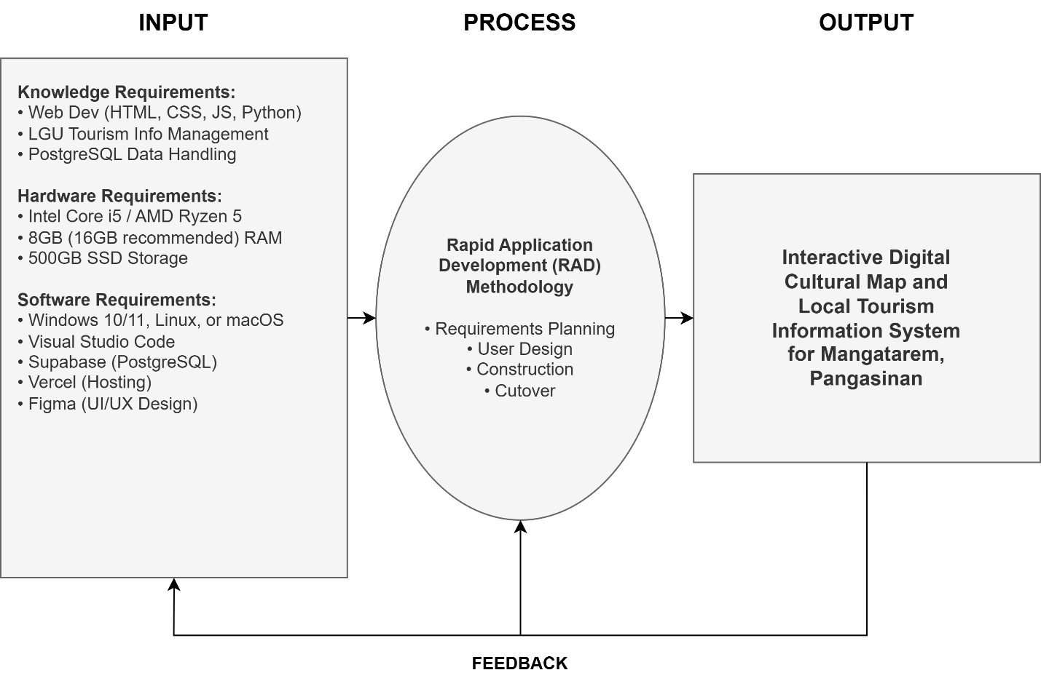
Figure 1.1: IPO

The plan above shows how the project flows. The inputs of this study include the technical resources and knowledge needed to develop a system. The use of these inputs occurs throughout the iterative process as the system builds both incrementally and through the testing of each to create one final product the Interactive Digital Cultural Map and Local Tourism Information System that will operate as intended for the Local Government Unit (LGU) of Mangatarem and its stakeholder group. Continuous feedback is integrated during the process to assist with identifying and resolving challenges experienced during testing; consequently, providing an avenue for ongoing refinement in terms of quality.

Scope and Limitations

Scope
This project aims to create a web-based Interactive Digital Cultural Map and Local Tourism Information System (LIS) for the Local Government Unit (LGU) of Mangatarem, Pangasinan. The frontend will be built with HTML, Tailwind CSS, and Javascript using Vanilla JS tooling, while the server-side application logic will be built using Python, Flask Framework, and PostgreSQL with Supabase for cloud-native persistence and real-time capabilities. Design will be prototyped using Figma in order to support user interface (UI) and user experience (UX) design. This project will have three major components: an interactive map at the public-facing interface which enables users to browse, find, and filter tourist attractions and cultural heritage sites by category; a content contribution portal for authorized Barangay Representatives, along with a centralized administrative dashboard for LGU Tourism Office staff to moderate submissions, manage accounts, and post announcements; and structured access to archived cultural profiles and historical records for students and researchers to support academic data collection and heritage research.

Limitations
While the system has many features and functions, it has limitations on its use. One of these limitations is that it doesn’t have a way for users to book (or reserve) any type of lodging online or pay any kind of payment via online services. All of the features require a connection to the internet for use. Offline options for some types of use (such as using cached map tiles) are not available to use with the system. The system is intended for municipal level uses and the areas within Mangatarem, Pangasinan, but it is not designed to accommodate very large amounts of traffic without future infrastructure improvements (additional systems to support them). The content contribution and moderation modules are accessed only by authenticated LGU (local government unit) personnel and registered Barangay (municipality) representatives, meaning that the general public cannot directly submit data through map submissions. Additionally, the system is limited to the geographic and administrative boundaries of Mangatarem, Pangasinan, and does not cover other municipalities or provinces adjacent to them..

Definition of Terms
For clarity and consistency, the following key terms are defined operationally as they are used in this study:

Administrative and Stakeholder Users . This consolidated category refers to
the LGU Tourism Office staff (System Administrators) and authorized Barangay Representatives (Contributors) who hold internal access to the system. This category is responsible for submitting, reviewing, and approving cultural heritage data, managing the platform's operational integrity, and overseeing the municipality's digital tourism presence.

General Public and Academic Users. This category refers to tourists, visitors,
students, and researchers who access the system to navigate the interactive map, search for points of interest, and view published cultural and tourism information. These users consume the data for leisure, travel planning, or academic data gathering without requiring administrative privileges.

Interactive Digital Cultural Map.The core feature of the system that provides
a visual, geographical, and navigable representation of tourist spots, historical landmarks, natural attractions, and cultural heritage sites within the municipality of Mangatarem, Pangasinan. Users can interact with the map by clicking pins, filtering categories, and viewing detailed multimedia information for each location.

Local Government Unit (LGU). In this study, this refers specifically to the
municipal government of Mangatarem, Pangasinan, serving as the main beneficiary, authoritative body, and decision-maker over the tourism information system and its content governance policies.

Public User. Refers to tourists, visitors, or any general member of the public
who accesses the system to navigate the interactive map, search for points of interest, and view published cultural and tourism information without requiring a registered account or administrative privileges.

Rapid Application Development (RAD). The software development
methodology selected for this study, characterized by rapid prototyping, iterative feedback cycles, flexible requirements gathering, and continuous stakeholder involvement to accelerate system construction while maintaining alignment with user needs.

Content Moderation. The process by which the System Administrator reviews
content submissions from Barangay Representatives and decides whether to approve, reject, or request revisions before the content is published on the public-facing interactive map.

(RRL Verification Concern
- Wilson (2025)
- Reyes (2024)
- Smith (2023)
-Cruz (2022) paki include mga ito sa REFERENCES)

(Hindi ko ma-verify kung totoong published references ang mga ito.
Maraming AI-generated manuscripts ang gumagamit ng:
- Smith
- Wilson
- Brown
- Taylor
- Anderson
WALANG ACTUAL SOURCE.)

Review of Related Literature
We’ve gathered these studies to back up our goals for the Mangatarem project. We focused on research from 2020 to 2025 that shows why digital maps and better data management are so vital. We’ve organized these into local and foreign studies to show how they help us hit our four main objectives.

Local Studies
Existing Tourism Information Management Processes in Philippine LGUs

Soncuya (2020) looked at how groups like the NCCA and local offices work together on cultural maps. He found that many towns still use messy, split-up methods that lead to wrong data. But he also showed that a clear legal plan helps these projects last. This helps us with our first objective because it proves we need a structured way to report facts in Mangatarem.

Coro II and his team (2022) studied how Siargao moved to a digital setup. They found that the system actually worked because they got local leaders involved from the start. This supports our work because it shows that a digital platform helps rural towns stay accurate and organized. It gives us a real-world example for our fourth objective on how to roll out the system.

Zuniga (2023) tested how provincial maps work when you mix history with GPS data. He found that letting local people upload info while experts checked it made the data much better. This confirms our plan for the second objective, where we let barangay leaders be the ones to share their own local stories.

Usability, Intangible Heritage, and System Acceptance

De Vera and her colleagues (2022) looked at how local festivals help a town’s economy and pride. They discovered that putting these events online makes people much more interested. This backs up our second and third objectives since we want to include things like event calendars and photo galleries to see if users find them helpful.

Mendoza (2021) pointed out the big hurdles in saving a town's history, like running out of money or not having a plan to keep the site running. She suggested that a town needs the community's help to keep things alive. This helps us with our fourth objective because it warns us about what could go wrong if we don't have a solid maintenance plan.

Foreign Studies
Digital Transformation and Technological Frameworks
Kumar and Singh (2022) built a web map that used old photos to show how a place changed over time. They found that seeing "then and now" photos makes users feel more connected to the history. This fits our first and second objectives because it gives us a technical model for how our map can show Mangatarem’s past.
Chen and his fellow researchers (2024) found that maps with stories and galleries kept people looking 40% longer than plain sites. They argued that a good-looking site is the biggest reason people keep coming back. This helps us with our second objective by proving that things like photo galleries are vital features for our map.

User-Centric Design and Evaluation Standards

Wang (2023) explained that you can't just map buildings; you also have to map traditions and festivals. He showed that a town runs much better when its data includes both physical spots and local habits. This supports our second and third objectives by giving us a framework for what kind of categories we should use on our site.
Tan (2023) built a travel site that suggested places based on what users liked. He found that if a site is easy to use from the start, people won't fight the change. He also suggested making the software in parts so it's easy to update later. This helps us with our second and fourth objectives as we plan out our filters and how we'll deploy the system.
Petrovic (2022) looked at how to keep heritage sites safe in tropical areas using software. He found that systems that let people monitor conditions regularly were much more accurate. This backs up our third and fourth objectives because it shows why we need to test our security and have a plan for regular data updates.

Chapter II
Methodology and Design

The methodology and design strategies used for the development of the Interactive Digital Cultural Map and Local Tourism Information System for Mangatarem, Pangasinan are presented in this chapter. In addition, a systematic account will be made of the software development methodology and processes, including: 1. The data sources and techniques that were used to gather user requirements; 2. The design artefacts that were used to guide the construction of the system; and, 3. The implementation plan, including a description of deployment procedures and resource requirements for the successful delivery of a functional and sustainable tool for use by the Local Government Unit (LGU).

Software Development Methodology
Software Development Methodologies (SDMs) serve as a structured method that provides guidance on how to plan, design, code, and test a project throughout its entirety. Adopting an SDM allows for a more organized approach to managing the development process by ensuring timelines are met and all aspects of the system meet user’s needs. The current study on Mangatarem utilizes a formally adopted methodology to govern its development of the digital mapping application, ensuring that the finished product meets all the workflow requirements of the Local Government Unit (LGU).

The project combines the use of Rapid Application Development (RAD) with a Participatory Geographic Information System, or PGIS. RAD was chosen because it relies heavily on rapid prototyping and continuous user feedback throughout the development lifecycle. Because of the potential for fluctuating tourism data and the needs of the barangays to change during system development, this will facilitate the ability to make modifications as necessary. As well, by using a PGIS, it is anticipated that the involvement of local community members representing their culture and geographical area will result in improved accuracy and relevancy of data incorporated into the final system.

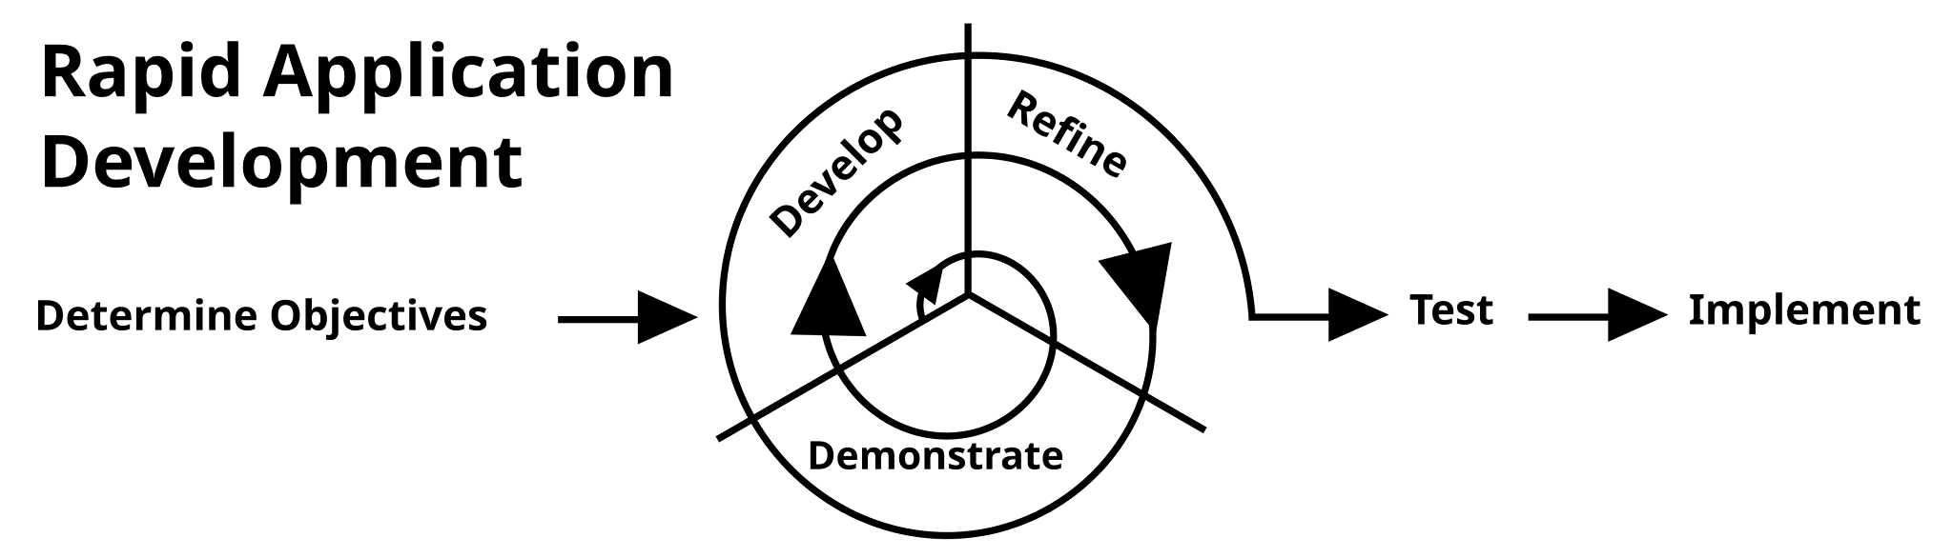
Figure 2.1 Rapid Application Development (RAD)

Rapid Application Development (RAD), is an agile methodology for developing software quickly, with continual feedback from users. Instead of doing all of the system specification upfront, RAD uses iterative prototype development, where small, as useful as possible versions of software systems are built and then refined through repeated cycles. Because of this, RAD is designed to keep the end-user engaged throughout the project, receiving feedback that can directly impact advancements made to the system. RAD is especially well suited for projects that require strong interface design and a focus on the user experience and where the needs of the users will expand as the stakeholders have opportunity to interact with the actual prototype implementations.

The team broken down our work into these four RAD phases:

- Requirements Planning: We started by meeting with the LGU Tourism Office staff to find the gaps in their current manual filing system. We identified the main goals and defined the two primary user categories: Administrative and Stakeholder Users (LGU staff and Barangay Contributors) and General Public and Academic Users (Tourists and Researchers). We used interviews and site visits to make sure we didn't miss any important cultural traditions or landmarks that the town wants to highlight.
- User Design (Prototyping): Once we knew what the system needed, we used Figma to create mockups and wireframes. We built designs for the interactive map (Public/Academic interface) and the data management portals (Administrative/Stakeholder interface). We showed these to the LGU staff and barangay reps to see if they found the buttons and menus easy to navigate. We used their feedback to change the layout until it felt just right.
- Construction: This is the phase where we did the actual coding. We used HTML, Tailwind CSS, and JavaScript for the parts you see on the screen, and Python with Flask for the logic and database work. We stored all the town's information in Supabase. We built the interactive map and created the "approve or reject" moderation workflow for the administrative users. We coded and tested in small cycles so we could catch and fix bugs early.
- Cutover (Testing and Deployment): In this final stage, we perform functional, security, and usability tests to make sure the site is safe and fast. Once we resolve any issues, we’ll launch the system for the LGU. We’ll also hold training sessions for the Administrative and Stakeholder category (LGU staff and barangay leaders) and give them user manuals so they feel comfortable running the site on their own.

Sources of Data
The primary sources of data for this project are individuals, groups, and locations within the municipality of Mangatarem, Pangasinan that hold crucial tourism, cultural, and historical information relevant to the system. Key data sources include:

- LGU Tourism Office Staff — Municipal tourism officers who provide official tourism policies, existing manual records, promotional materials, and municipal-level tourism initiatives. They serve as the authoritative source for content moderation rules, user access policies, and platform governance requirements.
- Barangay Officials and Representatives — Designated individuals from each barangay who serve as vital sources for localized cultural data, specific landmark descriptions, community event schedules, and grassroots heritage information that is not centrally documented at the municipal level.
- Manleluag Spring National Park and Other Tourist Sites — Physical locations within Mangatarem that serve as points of reference for mapping coordinates, photographic documentation, and on-site observation of existing visitor information systems (e.g., signage, brochures).
- Municipal Archives and Physical Records — Existing physical tourism brochures, printed municipal profiles, historical documents, and past tourism reports maintained by the LGU, which serve as secondary data sources to establish the initial database content of the system.

Data Gathering Techniques
To ensure a comprehensive understanding of the current operational challenges, cultural preservation needs, and technical requirements for the Interactive Digital Cultural Map and Local Tourism Information System for Mangatarem, Pangasinan, multiple data gathering techniques were employed. These techniques were carefully selected and implemented to collect both qualitative and quantitative data from key municipal stakeholders and community representatives.
Surveys and Questionnaires - One of the primary techniques used was the survey questionnaire. These were distributed to selected LGU Tourism Office staff, Barangay Representatives, and potential academic users during the initial Requirements Planning phase. The surveys were designed using structured questions to assess data usage habits, preferred public-facing features (e.g., map filtering vs. list view), and the frequency of data synchronization issues caused by current manual reporting methods. The data collected helped the development team prioritize key system features such as the Content Moderation workflow and the multi-layered interactive map categories that would directly address user needs and information gaps.
Interviews - Another method applied was the interview technique, conducted with key personnel, specifically the LGU Tourism Officer, municipal archivists, and authorized Barangay Officials. These interviews were semi-structured, allowing participants to elaborate on the burdens of manual, paper-based record-keeping and the difficulties in verifying facts for public dissemination. The interviews took place during the first phase of project development and provided in-depth qualitative data that supplemented the survey results. This approach enabled the developers to understand specific pain points, such as the delays in updating tourism status, manual tracking of cultural assets (Forms 01-07), and the lack of a centralized platform for official announcements.
Observation - Direct observation was also utilized to study how LGU staff and Barangay Representatives interact with the existing manual processes. The developers observed the day-to-day operations, including how tourist inquiries are currently answered by manually flipping through physical files and how updates are received via text messages or informal calls. By witnessing the processes firsthand, the development team was able to document procedural gaps, such as the risk of data fragmentation when information is sourced from unverified social media, and operational bottlenecks that validated the urgent need for a standardized, digital content submission portal.
Document Analysis - In addition, document analysis was performed on existing municipal tourism brochures, historical profiles, official NCCA cultural profiling forms (Forms 01-07), and municipal-level archival records. This technique helped the researchers assess how records were currently being maintained, the consistency of the data structure, and the extent of manual documentation errors. The analysis also provided a clear benchmark for the type of data, such as geospatial coordinates, heritage significance, and required metadata, that the Interactive Digital Cultural Map would need to digitize and manage.
These data gathering techniques, applied during the initial planning and design stages, ensured that the development of the Interactive Digital Cultural Map and Local Tourism Information System for Mangatarem, Pangasinan was informed by real-world LGU practices, grounded in municipal needs, and aligned with the town's goals for cultural preservation and digital tourism.

System Design

System Architecture
The structured blueprint that describes the parts, relationships, and data flow of a software system is called a system architecture design. It is essential in defining how users, technologies, and procedures are combined to accomplish the application’s functional objectives. Efficiency, scalability, security, and maintainability are guaranteed by a well-designed system architecture, particularly in web-based solutions that support numerous users and roles.
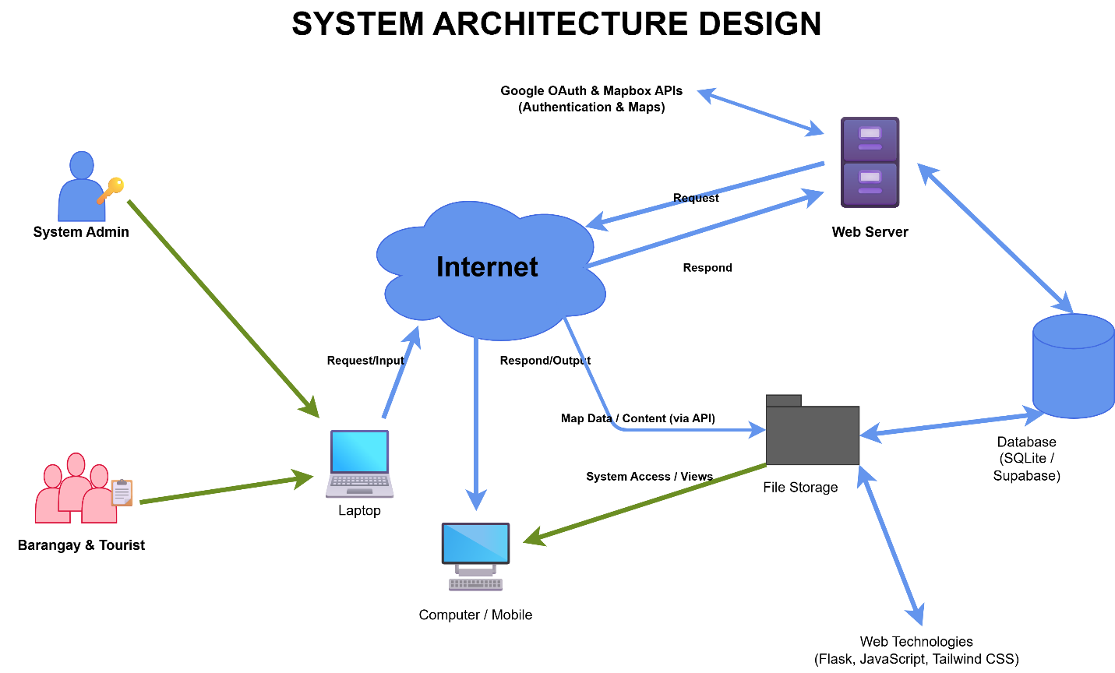
The system architecture design for the IT capstone project, Interactive Digital Cultural Map and Local Tourism Information System for Mangatarem, Pangasinan, clearly illustrates how users engage with the application, how data is processed and stored, and how services are provided via a modern cloud-native web platform.

Figure 2.2 System Design
System architecture design is a foundational blueprint of a software system that includes its basic components and how users will be interacting with it, as well as how data will be flowing through it. The primary goal of a system architecture design is to define how users, technology, and processes integrate in order to achieve the functional and operational objectives of a software application. A well-designed system architecture is important in ensuring the efficiency, scalability, and security of a software application. For the IT Capstone Project, "Interactive Digital Cultural Map and Local Tourism Information System for Mangatarem, Pangasinan," it is evident that through the system architecture diagram, users will be able to have a clear and visualized understanding of how they will be interacting with it and how data will be processed and made available through the web application in a secure manner.
The diagram provided in this section describes the system architecture for the "Interactive Digital Cultural Map and Local Tourism Information System for Mangatarem, Pangasinan." This diagram indicates the main user roles for the proposed system, which are the General Public, Tourists, LGU Administrators, and Barangay Representatives. These user roles will be able to access the proposed system through a variety of client devices such as desktop computers, laptops, tablets, and mobile phones. These client devices will be able to access the proposed system via HTTP or HTTPS protocols over the internet, which is considered the medium of communication for these devices and the server.
At its heart lies the application and presentation layer that powers the interactive mapping experience. The front-end utilizes HTML, Tailwind CSS, and JavaScript, heavily integrated with Mapbox GL JS, which is in charge of handling the dynamic geospatial rendering and interactive map markers. The server-side logic is driven by Python and the Flask framework, deployed in a serverless environment via Vercel to handle business logic, content moderation, and spatial queries. The server retrieves and serves these resources, whereas transactional data, cultural asset records, and user coordinates are securely read from or written to a Supabase PostgreSQL database. Additionally, an Upstash Redis caching layer processes high-frequency queries to manage vital records efficiently and ensure fast map loading speeds.
In conclusion, the system architecture design provides an overall framework for the development of the proposed system. It provides a secure system of access based on roles, allows for highly responsive web access from various devices, and facilitates the interaction of the front-end user interface and the back-end geospatial data services. It clearly defines the relationships between the user, devices, system components, and data repositories. Therefore, the development team is able to create a robust, cloud-native system that is strictly tailored to the needs of the cultural preservation and tourism operational processes of the Mangatarem LGU.

Existing Process Flowchart
System architecture design provides a high-level structural overview of a software system, defining how different technological components interact—from the user's device to the backend database—to deliver the system's services. A clear architecture is important because it establishes the blueprint for the system's technical structure, ensuring that all components are properly integrated, scalable, and secure. For the IT Capstone Project, "Interactive Digital Cultural Map and Local Tourism Information System for Mangatarem, Pangasinan," it is evident that the system architecture diagram provides a clear and visualized understanding of how users will be interacting with the platform.

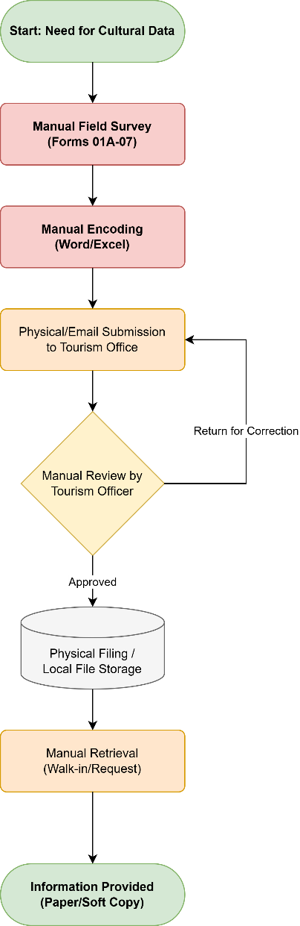

Figure 2.3 Existing Flowchart
The flowchart illustrates the two primary manual processes currently used in Mangatarem, revealing significant gaps in information accessibility and data synchronization. The first process (Top Path) begins when a tourist seeks information. Currently, the tourist is forced to choose between searching unverified social media pages—which often harbor outdated or conflicting details leading to visitor confusion—or traveling physically to the Municipal Tourism Office. At the office, staff must manually browse through paper-bound records and physical files to answer inquiries. If the relevant file is missing or being used by another officer, the information remains unavailable, resulting in a poor visitor experience.

The second process (Bottom Path) describes the current information reporting workflow from the grassroots level. When a Barangay Representative has a new cultural event or attraction update, they must either prepare a physical report for delivery or send informal messages via text or social media. This non-standardized communication forces LGU Tourism staff to manually consolidate disparate data formats. Any missing information necessitates a repetitive cycle of phone calls and follow-ups, causing significant time lags. By the time the LGU updates its printed brochures or social media posts, the information is often already weeks old. This flowchart demonstrates that the current reliance on manual, physical-first documentation is the root cause of the municipality's fragmented and delay-prone tourism information ecosystem.

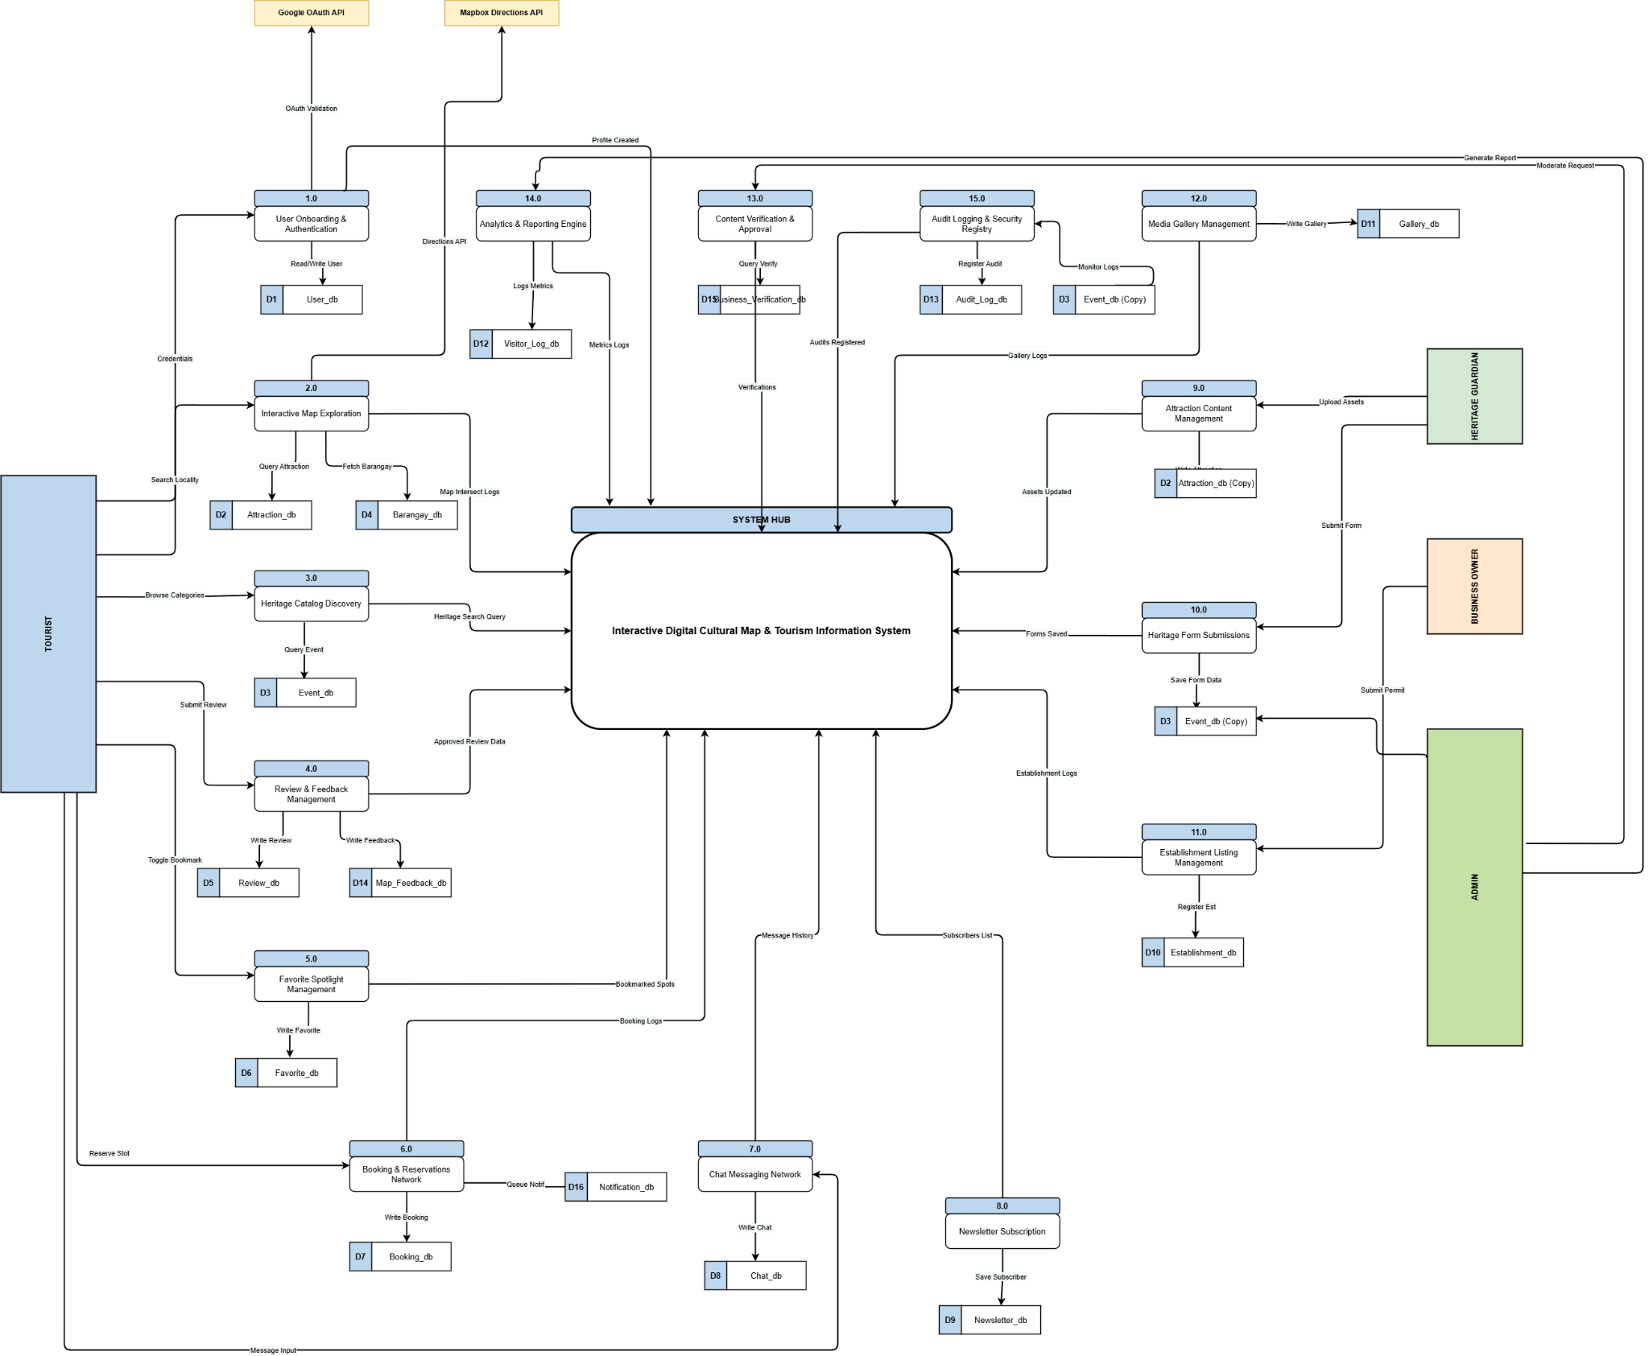

Figure 2.3 Dataflow Diagram

Dataflow Diagram (DFD)
A Data Flow Diagram (DFD) is a logical representation of a system's primary processes and how it interacts with external entities and data stores . It outlines the structural boundaries of the application and the major data exchanges within and outside the system without highlighting specific implementation details . Unlike detailed process flows, the DFD provides a holistic overview of data handling, making it easier for developers and stakeholders to validate system requirements. For the Interactive Digital Cultural Map and Local Tourism Information System for Mangatarem, Pangasinan, this diagram serves as a foundational visual aid that guides system developers, stakeholders, and future users in understanding the flow of data between the system and its external actors . It is particularly helpful in identifying external user roles—such as General Public and Academic Users (EE1) and Administrative and Stakeholder Users (EE2)—system inputs and outputs managed by core processes like Search & Browse, Content Submission, and Content Moderation, and the interaction with internal data repositories such as User Accounts & Roles (D1) and Tourist Spots & Cultural Data (D2) .
This section shows a Dataflow Diagram (DFD) which displays all key system interactions that the proposed system will operate through. The system which is identified as [0 Interactive Digital Cultural Map and Local Tourism Information System for Mangatarem, Pangasinan] establishes connections to two main external entities which are the General Public / Tourists and the LGU Admin / Barangay Representative. Data Flow Lines which show inbound and outbound user activity create relationships that describe how data moves through the system from submission to processing and storage until it reaches output.
The Data Flow Diagram (DFD) for the Interactive Digital Cultural Map and Local Tourism Information System for Mangatarem, Pangasinan shows how the system connects to its main external systems which include the public users and municipal administrators, and to its internal data storage systems that support system operation. The core model demonstrates how data flows into the system and through specific processes and out of the system which helps identify system limits and main operational processes.
The General Public / Tourists serve as a key external entity that interacts with the system in several essential ways. Users begin their interaction by submitting their search queries, viewing requests, and community feedback or cultural contributions into the system. The system processes these requests and then sends back to the user the rendered map data, rich cultural narratives, search results, and system notifications. This continuous flow of data ensures that tourists and the general public have seamless, real-time access to the municipality's heritage and tourism information.
The LGU Admin / Barangay Representative serves as another main external entity who establishes contact with the system to perform their moderation and data management duties. These administrative users begin by submitting their authentication details to access the system and, in return, receive their authentication status along with their secure dashboard views. Once properly authenticated, administrators use the system to submit updated content, account updates, and approval or rejection commands for user-submitted contributions. The system processes these administrative inputs and outputs moderation queues and comprehensive audit logs back to the administrators to help them oversee the platform's content integrity.

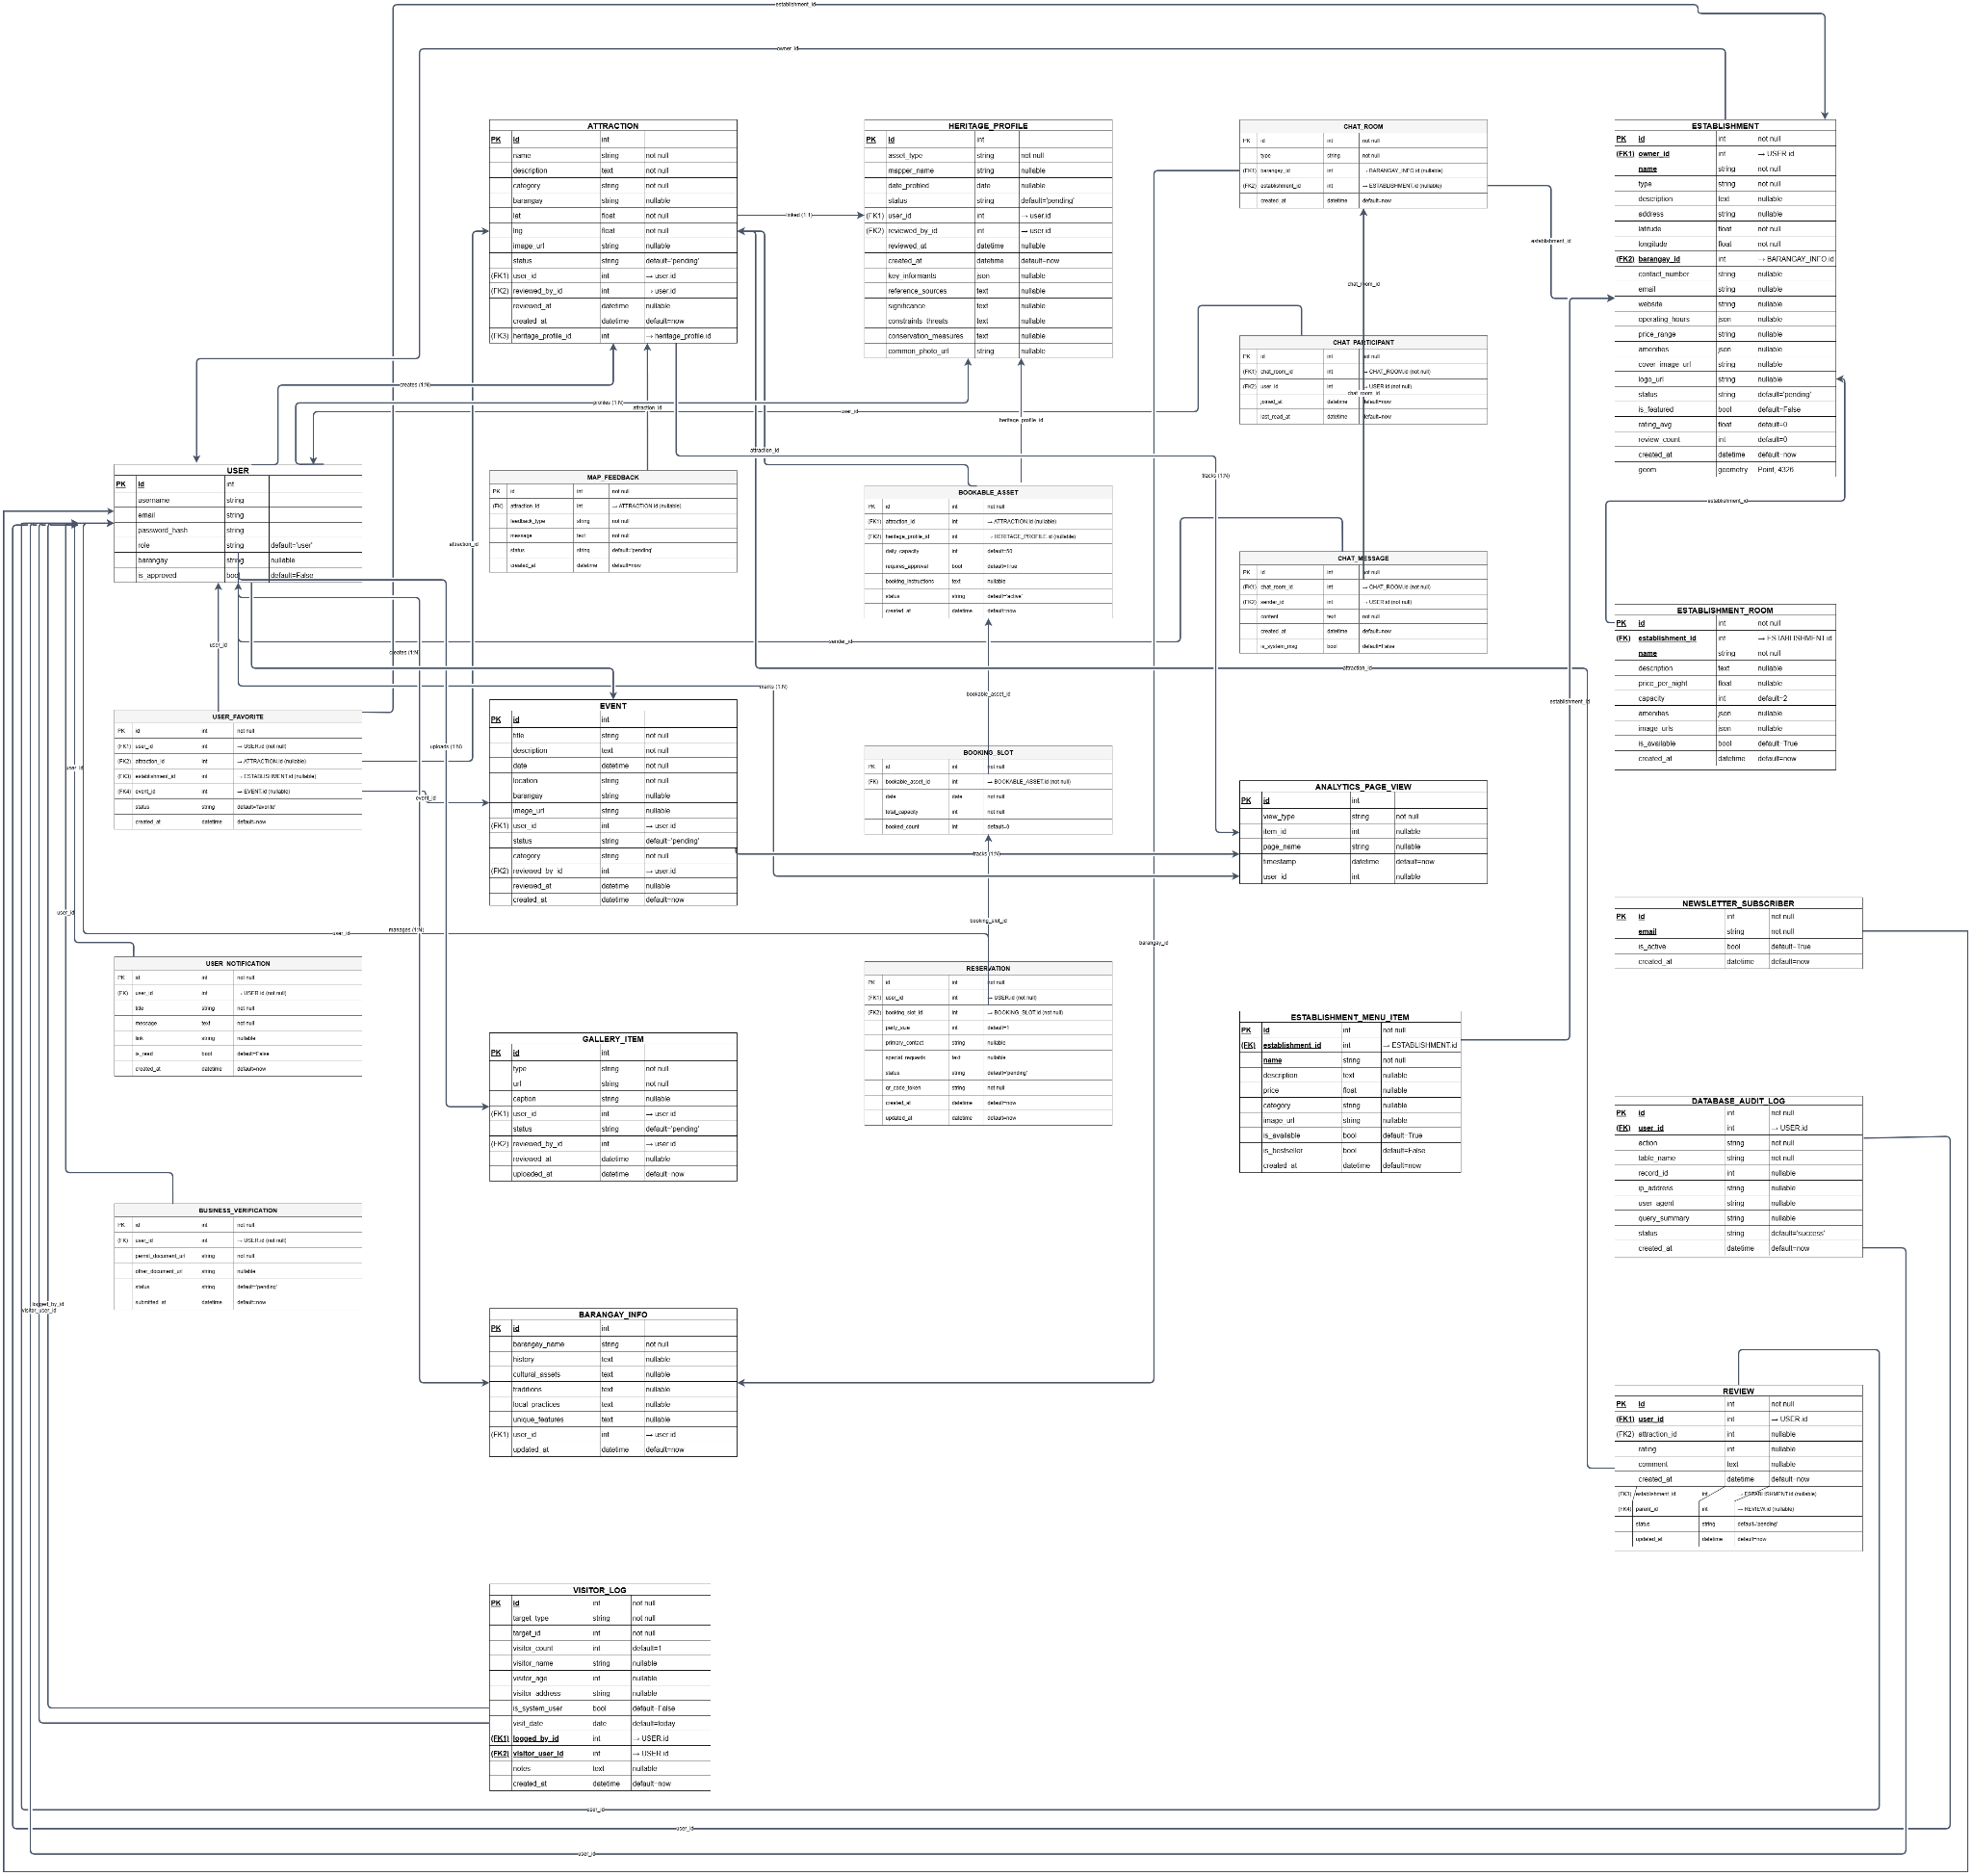

Figure 2.4 Entity Relationship Diagram

Entity-Relationship Diagram (ERD)
An Entity-Relationship Diagram (ERD) is a graphical representation of a system’s data structure that illustrates the entities involved in the system, their attributes, and the relationships between them. It is an essential tool in database design, providing developers with a clear understanding of how data is stored, connected, and accessed within a system. In the context of the Interactive Digital Cultural Map and Local Tourism Information System for Mangatarem, Pangasinan, the ERD plays a crucial role in guiding the logical structure of the database. It ensures that all core entities such as user accounts (General Public, Tourists, LGU Administrators, and Barangay Representatives), tourist spots, cultural heritage profiles, spatial coordinate records, and community contributions are accurately represented and properly linked, thereby supporting the system’s goal of digitizing local heritage, streamlining tourism information management, and securely processing interactive map data efficiently.
Presented in this section is the Entity-Relationship Diagram (ERD) that maps the database architecture of the proposed Interactive Digital Cultural Map and Local Tourism Information System for Mangatarem, Pangasinan. This model illustrates the fundamental data entities—representing users, geographic anchors, cultural registries, and business transactions—and the logical relationships connecting them. It serves as the data blueprint for how information is organized, stored, and retrieved to support the system’s core functionalities.
At the foundation of the system's security and accountability is the user entity. To manage authorization efficiently, the system tracks distinct administrative roles (such as Admin, Barangay Contributor, Business Owner, and Guard) directly tied to the primary user records. The user entity connects to security and data validation tables such as password_reset_token to facilitate secure, self-service account recovery. This design ensures that municipal stakeholders and content managers are securely granted the appropriate system privileges while maintaining strict system-wide transparency through a database_audit_log.
Beyond basic access, the database structure is geographically anchored by a central barangay_info entity. This entity serves as the regional backbone of the system, connecting physical landmarks and administrative boundaries within Mangatarem to other specialized files. The barangay_info records branch out into key descriptive profiles, capturing specific localized datasets for various assets. This centralized localization layout ensures that user accounts, heritage documentations, local festivals, and commercial businesses are accurately mapped and organized relative to their specific municipal barangay.
The core administrative process of cultural preservation is captured through a standardized documentation pipeline. A heritage_profile entity handles the official registration of cultural assets, meeting strict national profiling benchmarks for tangible and intangible heritage. To optimize public tourism visibility, a heritage_profile can link directly to an optional attraction entry. This structured link from a formal archive to a visitor-facing profile ensures smooth data transitions from municipal record-keeping to an interactive public mapping experience that highlights local landmarks and scheduled event occurrences.
To manage local commercial and hospitality tourism details, the system relies on a central transactional establishment entity. The establishment table acts as an operational intersection where local business records are cataloged and further segmented based on their specific services. Lodging-focused businesses branch into granular establishment_room entities, while dining options feature culinary catalogs tracked via establishment_menu_item. This modular design allows local business stakeholders to cleanly organize, manage, and showcase their commercial offerings under a single unified enterprise presence.
Fulfilling the system's interactive engagement and public outreach capabilities, several entities are dedicated to tracking public evaluation and security logging. Visitors interact with the application by submitting testimonials and numerical ratings stored within establishment_review, which are visually verified via linked review_photo assets, or by saving references via user_favorite_establishment. Simultaneously, the platform processes community engagement through a newsletter_subscriber list, while localized security checkpoints feed visitor entry and exit details into a visitor_log entity to provide the LGU with comprehensive data-driven mobility insights.
In summary, the ERD provides a holistic view of the cultural map and tourism platform's data structure. By establishing clear relational links between secure user roles, regional geographic anchors, standardized heritage records, commercial listings, and public interaction logging, the design ensures high data integrity. This robust foundation is vital for executing the complex geospatial rendering, cloud-native content moderation, and multi-layered local tourism analytics required by the Mangatarem management system.

Implementation Plan
The implementation plan for the Interactive Digital Cultural Map and Local Tourism Information System for Mangatarem, Pangasinan serves as a strategic roadmap to transition the project from development to a fully operational state. Utilizing the Rapid Application Development (RAD) methodology, this plan emphasizes iterative refinements and active stakeholder involvement to ensure the final system effectively addresses the decentralized cultural documentation and manual tourism dissemination challenges faced by the Mangatarem Local Government Unit (LGU).
A Gantt Chart is essential for visualizing the development schedule, illustrating the sequence and duration of tasks while identifying key personnel for each phase. In the context of this project, the timeline is structured around the four primary stages of the RAD model—Requirements Planning, User Design, Construction, and Cutover ensuring a goal-oriented approach to system completion.
The project timeline is strategically structured over a sixteen-week period from February to May 2026, following the iterative phases of the RAD model to ensure rapid delivery and high alignment with institutional needs.

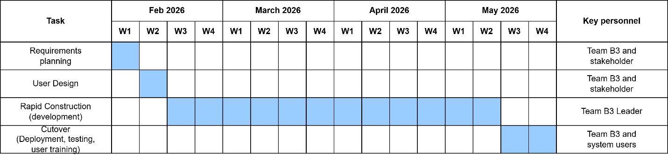

Figure 2.5 Project Timeline

The first phase, Requirements Planning, is carried out during the first week of February 2026. This early stage involves the research team and key stakeholders focusing on finding the gaps in the current manual filing system and defining the core requirements for the Administrative and Stakeholder Users along with General Public and Academic Users to establish a technical blueprint tailored to the administrative and preservation needs of the Mangatarem LGU. The second phase, User Design, takes place during the second week of February. During this stage, the researchers collaborate with LGU staff and barangay representatives to create and refine mockups and wireframes for the interactive map and data management portals using Figma, ensuring usability through continuous feedback.

Rapid Construction, which forms the technical core of the project, is implemented from the third week of February through the end of April 2026. Led by the development team, this phase involves iterative coding in short cycles using HTML, Tailwind CSS, and JavaScript for the presentation layer and Python with Flask for the server-side business logic, while integrating the Supabase primary database and building the interactive mapping and content moderation workflows. The final phase, Cutover, is scheduled for the first and second weeks of May 2026. This concluding task involves the full team and municipal system users, focusing on finalizing the system, conducting rigorous functional, security, and usability testing, and performing comprehensive user training sessions for the LGU staff and barangay leaders to ensure a smooth transition to the official public launch.

Deployment Plan
The deployment plan outlines the final steps for the successful installation and launch of the system within the Mangatarem Local Government Unit (LGU) operational environment. Deployment is scheduled for the final weeks of the project timeline, marking the culmination of all development iterations. During this phase, the completed system will be migrated to a live cloud production environment utilizing Vercel for frontend and serverless backend execution, paired with Supabase for database management and Upstash Redis for optimized caching. System users, including the LGU Tourism Office staff and selected Barangay Representatives, will participate in internal Pilot Testing to verify that the end-to-end content moderation workflows and interactive geospatial mapping features function correctly. Identified issues and user feedback will be resolved promptly to ensure stability before the full launch. Following successful testing, structured training sessions will be conducted, and user manuals will be distributed to equip LGU administrators, barangay leaders, and local business owners with the knowledge needed to navigate the heritage profiling, business listing updates, and digital moderation portals effectively.

Resource Requirements
The successful implementation and long-term sustainability of the system depend on several critical hardware, software, and human components. Regarding Hardware Resources, development is supported by machines equipped with a minimum of an Intel Core i5 or equivalent processor with 8GB RAM (16GB recommended) and SSD storage. For daily operational use, the designated LGU operator workstation at the Tourism Office requires a similarly capable desktop or laptop with at least an Intel Core i5 and 8GB RAM. Meanwhile, end-users such as Public Users, Barangay Representatives, and Students or Researchers will require standard smartphones, tablets, or personal computers with web browser access.
A stable internet connection is essential across all devices, as the system is cloud-based and requires real-time data synchronization for the interactive map and moderation portals.
Software Resources include the use of Visual Studio Code as the primary development environment, Figma for UI/UX prototyping and wireframing, Python 3.12+ along with the uv package manager, and Git for version control. The system itself is built on a modern stack utilizing HTML, Tailwind CSS, and JavaScript with Mapbox GL JS for the frontend, and Python with the Flask framework for the backend, supported by a Supabase PostgreSQL database and Upstash Redis caching. From a Human Resource perspective, the development team—composed of Jem Carlo Austria, Mary Jane Dalas, Rea Solis, and Joy De Guzman—is responsible for executing the system's development, deployment, and technical troubleshooting. The active participation of the LGU Tourism Office staff and designated Barangay Officials and Representatives is vital during the testing, training, and operational phases to ensure the system is ready to meet the daily demands of preserving and disseminating the cultural heritage of Mangatarem.

Chapter III

RESULTS AND DISCUSSION
This chapter presents the comprehensive results of the design, development, and evaluation of the Interactive Digital Cultural Map and Local Tourism Information System for Mangatarem, Pangasinan. It includes the data flow diagrams and entity-relationship models, which illustrate the logical structure and digital workflow of the application, as well as an overview of the developed modules and user interfaces designed to support General Public and Academic Users, local Business Owners, and LGU Administrators. The chapter also outlines the outcomes of the system testing and evaluation processes, which were conducted to ensure that the system met all functional, security, and performance standards prior to its official deployment for the Mangatarem Local Government Unit (LGU) Tourism Office in Mangatarem, Pangasinan.
These testing activities included functional testing to confirm that core features such as the dynamic geospatial map rendering, the national-standard cultural heritage registry (Forms 01-07), and the multi-layered content moderation workflow operated as intended; security testing to evaluate the system’s role-based access control and the strict logging of administrative modifications within the immutable database audit logs; usability testing to assess the intuitiveness of the public mapping interface and administrative dashboard; and user acceptance testing (UAT) to gather direct feedback from the LGU Tourism Office staff and designated Barangay Representatives. Furthermore, this chapter presents the implementation results, detailing the cloud-native deployment strategy utilizing Vercel and Supabase, technical issues encountered during the iterative RAD phases, and the caching solutions implemented via Upstash Redis to optimize high-frequency queries and map loading speeds. The chapter concludes with a discussion of key findings that reflect the system’s effectiveness in digitalizing cultural narratives, enhancing local tourism information accessibility, and maintaining data stewardship accountability through a robust real-time synchronization framework.

Proposed System Flowchart

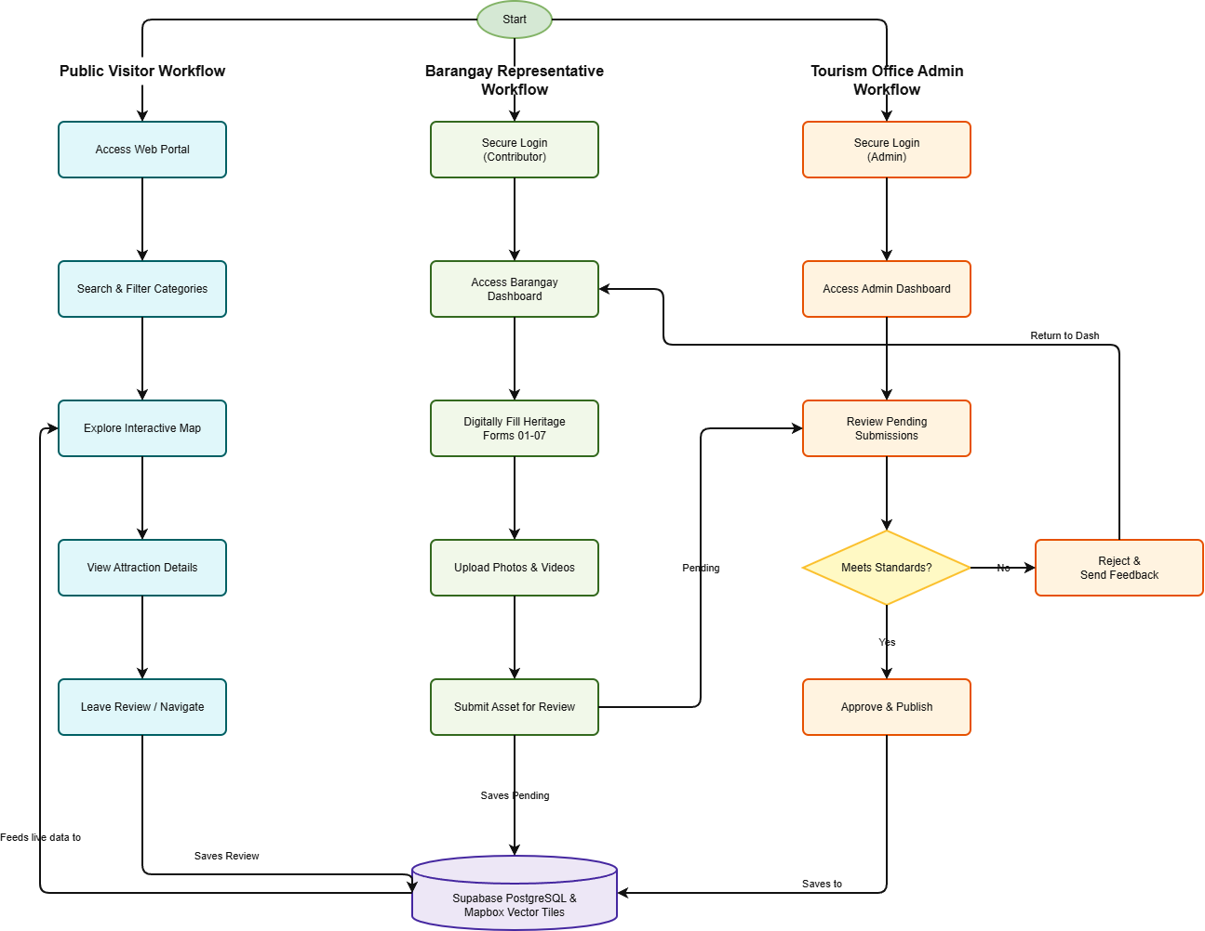

Figure 3.1 Proposed System Flowchart

Cultural Mapping and Content Moderation (LGU Workflow) Flowchart

The system workflow begins when a user initiates a session by accessing the digital web portal, prompting the main interactive map interface to load. For a Public Visitor, the workflow moves into the searching and filtering categories module, where they can refine their view by cultural categories or specific barangay boundaries. The system then processes this request to explore the interactive map, pulling data dynamically from the database to render custom visual pins directly on the screen. When a visitor clicks a pin to view attraction details, the system retrieves the full profile—complete with descriptions, hours, and photos—from the database repository. Finally, visitors can leave reviews or interactive feedback, which the system processes and immediately saves to update the live feed.

Barangay Representative Flowchart

For the Barangay Representative, the workflow begins with a secure login process that verifies their identity before granting access to their specialized Barangay Dashboard. From this workspace, representatives can digitally fill out heritage forms 01–07 using standard inventory layouts and upload associated photos or videos. Once they submit the asset for review, the workflow saves the submission under a "Pending" status within the Supabase database. This triggers the Tourism Office Admin workflow, where an administrator logs into the system with high-privilege credentials to access the central Admin Dashboard and review pending submissions.

Tourism Office Admin (Admin) Flowchart

The system then encounters a crucial administrative decision point: verifying if the asset meets official standards. If the coordinates or details are incorrect, the admin rejects the submission, attaches explanatory notes, and loops the workflow back to the representative's dashboard for correction. If the submission passes verification, the admin approves and publishes the asset; the system instantly changes its status to "Approved," updates the central mapping engine, and renders the new pin on the public map interface to complete the operational workflow.

System Features and User Interfaces
This section details the core functionalities of the Interactive Digital Cultural Map and Local Tourism Information System for Mangatarem, Pangasinan based on the defined data flow processes. The platform is designed with a role-based architecture to ensure data security, operational efficiency, and a streamlined workflow. Access is strictly divided between authorized personnel, specifically the LGU Administrators and the Barangay Representatives, alongside the public-facing interfaces designed for the General Public and Tourists.

Home

This feature enables the General Public and Tourists to visually explore the municipality's cultural and tourism assets. This includes interacting with the digital map, searching for local landmarks and businesses, and viewing verified heritage profiles to support public tourism engagement.
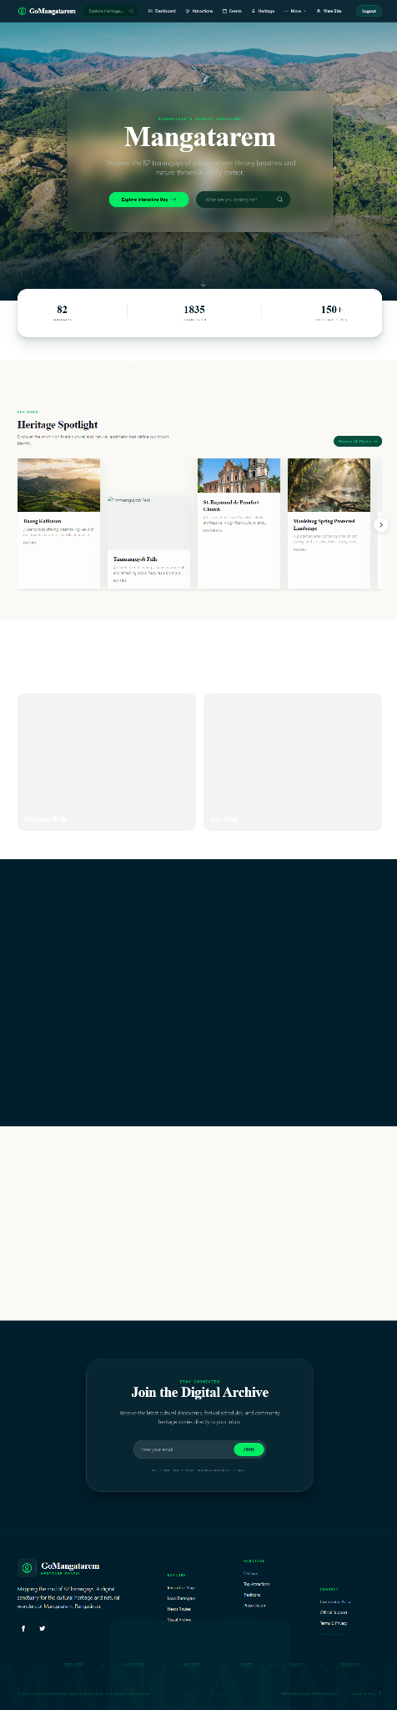

Figure 3.2 Home

This feature enables the LGU Tourism Office Admin to oversee the entire platform via a centralized dashboard. This includes monitoring site traffic, checking system statistics, and reviewing the queue of pending cultural asset submissions and business updates to ensure data integrity before public display.

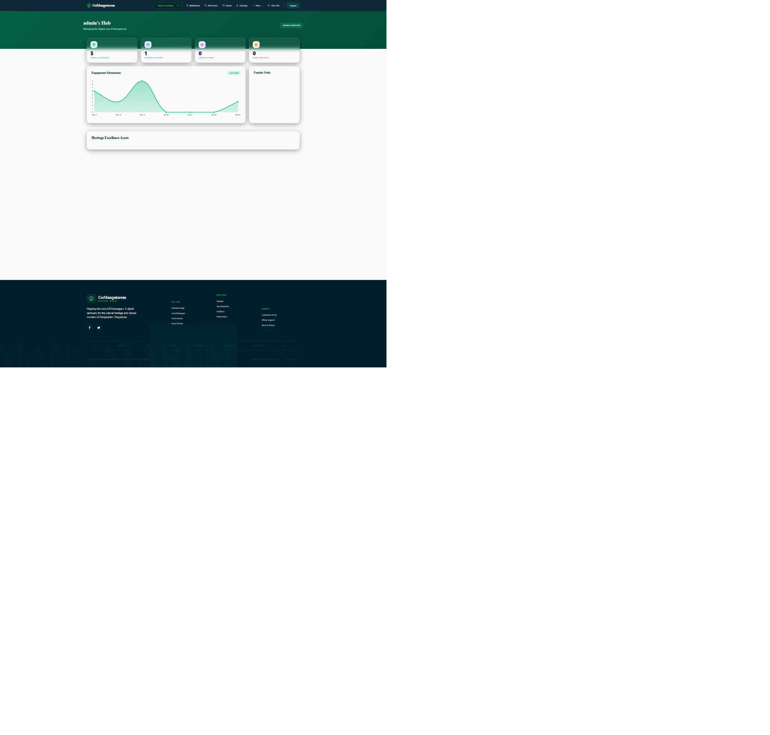

Figure 3.3 Dashboard

This feature enables the LGU Administrators and Barangay Representatives to securely access the platform's backend tools. This includes submitting authentication credentials (such as an email and password) to verify their identity and system role before granting them access to their respective data management portals and moderation dashboards.
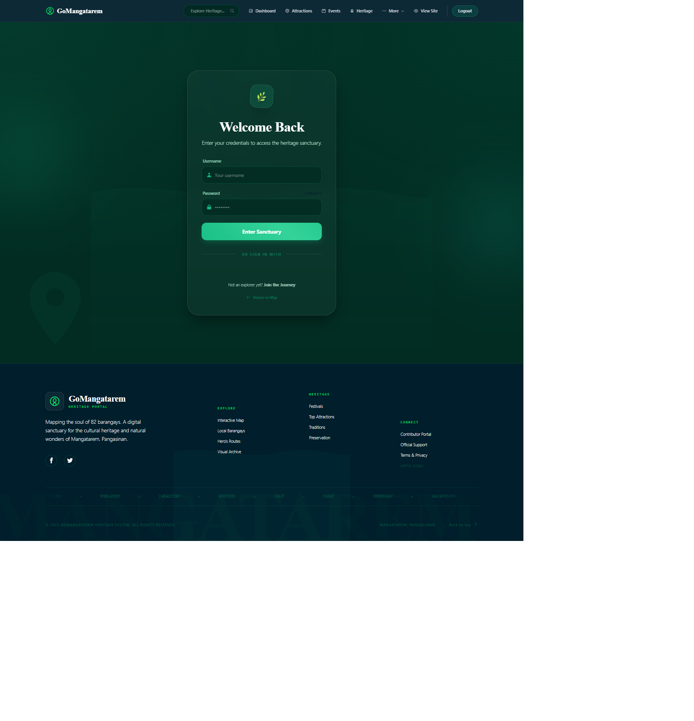

Figure 3.4 Login

System Testing Evaluation
The System Testing and Evaluation phase is a crucial component of the Software Development Life Cycle (SDLC), aimed at ensuring that the proposed Interactive Digital Cultural Map and Local Tourism Information System for Mangatarem, Pangasinan operates effectively, securely, and efficiently. This phase focuses on validating that the system meets its intended objectives, including the digital documentation of cultural heritage (Forms 01-07), dynamic geospatial map rendering, secure multi-layered content moderation, and centralized local tourism information dissemination. The evaluation process is designed to assess the system’s functionality, performance, security, usability, and overall acceptability among its intended users, namely the LGU Tourism Office Administrators, Barangay Representatives, Local Business Owners, and the General Public or Tourists. At this stage, the testing plan outlines the methodologies and approaches to be used in verifying system quality; however, actual testing results are not yet included.

Functional Testing
Functional Testing is conducted to verify that all system features operate according to the specified requirements and intended behavior. This includes validating core modules such as user registration and authentication, interactive geospatial map rendering, cultural heritage profile submission (Forms 01-07), the content moderation workflow, and local business directory management. The testing plan involves the creation of detailed test cases for each functionality, specifying inputs, processes, and expected outputs. For example, test scenarios will include successful account creation for a Barangay Representative, accurate placement of map pins based on coordinates, correct routing of submitted assets to the Admin moderation queue, and the proper publication of approved sites to the public map. Manual testing will be performed by simulating real user interactions across different roles. Each test case will be documented to determine whether the system produces the expected results or exhibits any functional errors, ensuring that all modules work cohesively prior to deployment.
Security Testing
Security Testing aims to evaluate the system’s ability to protect sensitive administrative access and maintain strict data integrity. Given that the system handles municipal records, user credentials, and an immutable database audit log, ensuring data security is a top priority. The testing plan includes validating authentication mechanisms, enforcing the role-based access restrictions between LGU Tourism Office Admins and Barangay Representatives, and ensuring proper data validation. Specific test scenarios will involve attempts to access restricted dashboard pages without authorization, submission of invalid or malicious inputs in public reviews, and testing for common vulnerabilities such as SQL injection and cross-site scripting (XSS). The expected outcome is that the system effectively denies unauthorized access, sanitizes user inputs, and protects the centralized Supabase database from exposure.
Usability Testing
Usability Testing is designed to evaluate the system’s ease of use, accessibility, and overall user experience for all intended users. This is particularly important as the system will be used by individuals with varying levels of technical expertise, from local barangay officials to general tourists. The testing plan involves the development of a structured usability evaluation instrument, such as a survey questionnaire utilizing a Likert scale. Participants, including LGU administrators, barangay representatives, and public users, will be asked to perform key tasks such as navigating the interactive map, submitting a cultural asset form, uploading multimedia files, and approving pending queue items. After completing these tasks, users will provide feedback on system navigation, interface clarity, map responsiveness, and overall satisfaction. Observations will also be recorded to identify any difficulties encountered during system interaction, ensuring the platform is both functional and intuitive.
User Acceptance Testing (UAT)
User Acceptance Testing (UAT) serves as the final validation phase to determine whether the system meets the expectations and requirements of its stakeholders. It ensures that the developed digital platform is suitable for actual operational use within the Mangatarem LGU Tourism Office. The testing plan includes defining real-world scenarios that reflect typical system usage, such as digitizing a new historical landmark, managing local business information, and updating public tourism announcements. Selected end-users, including the System Administrator and designated Barangay Representatives, will be invited to test the system using these scenarios. Participants will evaluate the system based on criteria such as functionality, reliability, efficiency, and overall satisfaction in transitioning from manual paperwork to a centralized digital mapping system. Feedback will be collected through structured evaluation forms and interviews, and any identified issues will be addressed prior to final public deployment.
Performance Testing
Performance Testing is conducted to assess the system’s responsiveness, stability, and efficiency under varying workloads. This ensures that the cloud-hosted architecture can handle normal and peak usage conditions without significant delays or rendering failures. The testing plan involves simulating multiple users accessing the system simultaneously, particularly focusing on high-demand scenarios like heavy tourist traffic during local festivals or bulk media uploads by contributors. Key performance indicators include page load time, the rendering speed of Mapbox GL JS spatial data, and the efficiency of the Upstash Redis caching strategy during concurrent operations. The expected outcome is that the Vercel serverless backend and Supabase database maintain acceptable performance levels without crashes or significant slowdowns, ensuring a seamless experience for both administrators and public visitors.

Implementation Results
The implementation of the Interactive Digital Cultural Map and Local Tourism Information System for Mangatarem, Pangasinan was conducted through a structured pilot deployment for the Mangatarem Local Government Unit (LGU) Tourism Office. During the final phase of development, the system was deployed in a controlled staging environment utilizing a cloud-native architecture powered by Vercel and Supabase. This pilot testing phase enabled the development team to observe the system’s actual performance, validate the integrity of the PostgreSQL database, and gather direct feedback from LGU administrators, barangay representatives, and public users who interacted with the platform.
As part of the implementation process, functional testing was conducted to verify that all core features operated according to the specified requirements and intended behavior. The researchers created detailed test cases for each module, including user authentication, interactive geospatial map rendering, cultural heritage profile submission (Forms 01-07), local business directory management, and the multi-layered content moderation workflow. Various testing scenarios were performed, such as successful account creation for barangay contributors, accurate placement of map pins based on spatial coordinates, and the proper routing of pending assets to the administrative approval queue. Manual testing was carried out by simulating actual user interactions under different system roles to ensure that all modules functioned cohesively and reliably.
During implementation, several minor issues were encountered. One issue involved slightly delayed loading times for the interactive map when rendering a large volume of cultural asset pins and high-resolution images simultaneously. This was resolved by implementing an optimized caching strategy using Upstash Redis and refining the Mapbox GL JS data fetching logic to cluster map points more efficiently. Another issue involved occasional permission overlaps within the moderation dashboard, which was quickly corrected by strictly enforcing the role-based access control (RBAC) logic in the serverless backend to ensure clear separation of privileges between barangay contributors and LGU approvers.
To ensure successful system adoption, orientation and training sessions were conducted for the LGU Tourism Office staff, designated Barangay Representatives, and local business owners. The training focused on transitioning from manual processes—such as searching through paper-bound records, updating physical files, and handling fragmented social media inquiries—into a centralized digital mapping and moderation platform. After completing the testing, debugging, and refinement stages, the implementation concluded successfully with a stable and functional web-based system capable of digitalizing cultural heritage, improving local tourism information accessibility, and enhancing the data stewardship efficiency of the Mangatarem LGU.

Discussion of Findings
The results of the conducted testing demonstrate that the system performs effectively in terms of functionality, performance, security, usability, and user acceptance. Based on the findings, the system successfully achieved its intended objectives and provided reliable support for the operations of the Mangatarem Local Government Unit (LGU) Tourism Office management and cultural preservation process.
In terms of Functionality Testing (100% Success Rate), the system successfully executed core features such as secure role-based login authentication, geospatial coordinate mapping, digital heritage profiling using standard Forms 01–07, multi-layered content moderation workflows, and local commercial directory updates. Most test cases passed successfully and produced the expected results within the Vercel and Supabase ecosystem. However, one specific issue was identified during the content moderation workflow where a Barangay Representative was strictly blocked from modifying or retracting an asset once it entered the administrative "Pending" queue, requiring a formal administrative rejection override to unlock editing capabilities. This finding highlights that while the automated moderation pipeline effectively enforces data validation rules and maintains strict historical integrity, additional localized draft-saving or intermediate editing permissions may still be required to provide greater flexibility for contributors before final submission.
For Performance Testing (100% Success Rate), the system demonstrated fast response times and stable operation under normal and simulated peak workloads. Administrative dashboard loading, multi-media asset uploading, geospatial pin rendering via Mapbox GL JS, and live local business search functionalities all executed within highly acceptable response thresholds. Due to the seamless integration of an Upstash Redis caching layer, high-frequency spatial queries and database retrieval operations completed within milliseconds, indicating that the system can efficiently process localized tourism data and public map interactions without causing latency or rendering delays to end-users. These results confirm that the system architecture is robust and capable of supporting daily municipal operations and tourist heavy-traffic periods in a responsive and efficient manner.
The Security Testing (100% Success Rate) results revealed that the system possesses strong protection against common web vulnerabilities, injection threats, and unauthorized system access attempts. All security test cases passed successfully, including brute force protection on the administrative portal, SQL injection prevention within the PostgreSQL backend, Insecure Direct Object Reference (IDOR) protection across administrative records, cross-site scripting (XSS) prevention on public review inputs, and malicious file upload blocking for multimedia heritage submissions. The implementation of strict server-side input sanitization, role-based access control (RBAC) validations, and the generation of immutable system logs within the database audit logging engine (DATABASE_AUDIT_LOG) contributed significantly to safeguarding municipal records and maintaining transparent, secure system operations. These findings indicate that the platform provides a highly secure environment for both LGU administrators and the general public.
Based on the Usability Testing (4.73 Success Rate - Agree), respondents provided highly positive feedback regarding the digital cultural map’s ease of use, interface layout, map navigation, and clarity of the heritage inventory forms. The system received high average scores across all usability criteria, particularly in user-friendliness, spatial filtering, and transaction feedback during asset uploads. Users found the web-based interface easy to navigate and understandable even with minimal technical effort, suggesting that the presentation layer effectively supports a smooth user experience for individuals of varying digital literacy levels, including rural barangay representatives. Although exact manual coordinate plotting and text-heavy instructional layouts for specific cultural categories received slightly lower ratings compared to other interactive elements, they still remained well within the positive evaluation range.
Similarly, the Acceptance Testing (4.40 Success Rate - Agree) results indicate a high level of overall satisfaction among the primary stakeholders. Respondents, including LGU Tourism Office staff, municipal leaders, and local business owners, strongly agreed that the system functions exactly as expected, performs efficiently, and completely addresses their operational requirements. The platform's ability to seamlessly transition manual, paper-bound tourism files, outdated printed pamphlets, and unverified social media information into an organized, single-source digital platform contributed greatly to user acceptance. These findings demonstrate that the developed interactive digital map is highly acceptable for practical, long-term implementation within the local government structure.
Overall, the testing results highlight several institutional and technical strengths of the system, including reliable geospatial data synchronization, rapid content retrieval, stringent security parameters, transparent audit tracking, and an intuitive user interface. At the same time, the findings also suggest key opportunities for further enhancement, particularly in improving contributor flexibility during the pre-moderation phase, refining fine-grained instructions for physical asset forms, and enhancing data handling in lower-bandwidth environments. Future development may focus on implementing an offline-first local storage module for remote barangay collection, optimizing visual asset compression, and providing controlled draft-saving features to further maximize the operational effectiveness of the municipal mapping ecosystem.

Analysis of Results

Functional Testing Analysis
Functional testing was conducted to ensure that all modules and features of the Interactive Digital Cultural Map and Local Tourism Information System for Mangatarem, Pangasinan operate according to the specified requirements.

Test Case | Expected Output | Actual Output | Pass/Fail | Remarks
Login with correct credentials | User is redirected to the dashboard | Works as expected | Pass | N/A
Submit heritage record form | Data is saved and appears in moderation queue | Record saved successfully | Pass | N/A
Search and filter heritage sites | System displays matching results | Results displayed accurately | Pass | N/A
Generate Heritage Summary | System produces detailed view of site | View rendered successfully | Pass | N/A

Table 3.1: Functional Testing
Functional Testing Success Rate Desciption
The system successfully executed essential functions which included secure user login credential validation, the successful submission of heritage record forms into the administrative moderation queue, the accurate searching and filtering of local heritage sites on the map, and the proper generation of detailed heritage summaries. According to the functional testing results, the system achieved a 100% success rate across all evaluated scenarios, seamlessly rendering expected outputs without encountering any operational problems or workflow blockages.

Success Rate Calculation: Success Rate = (Number of Passed Tests / Total Tests) × 100% Success Rate = (4 / 4) × 100% = 100%

Performance Testing Analysis
Performance testing was executed to evaluate the system's responsiveness, processing speed, and overall stability under standard operational workloads typical for the Tourism of Mangatarem environment.

Test Scenario | Expected Time (seconds) | Actual Time (seconds) | Pass/Fail | Remarks
Load homepage (1 user) | < 3 sec | 2.4 sec | Pass | N/A
Execute Spatial Query (Map Search) | < 5 sec | 1.2 sec | Pass | Optimized via Mapbox GL JS
API Response Time (Cached) | < 2 sec | 0.4 sec | Pass | Upstash Redis caching active

Table 3.2: Performance testing

Performance Testing Success Rate Description
The system successfully executed essential performance benchmarks which included loading the homepage in 2.4 seconds (well under the 3-second expectation), executing spatial queries for map searches in just 1.2 seconds (under the 5-second expectation), and delivering cached API response times in a rapid 0.4 seconds (under the 2-second expectation). The spatial queries were notably optimized via Mapbox GL JS, while the API response times were significantly accelerated due to the active Upstash Redis caching layer. According to the performance testing results, the system achieved a 100% success rate across all evaluated scenarios, seamlessly meeting and exceeding all expected response time thresholds without encountering any system slowdowns or rendering delays.

Success Rate Calculation: Success Rate = (Number of Passed Tests / Total Tests) × 100% Success Rate = (3 / 3) × 100% = 100%

Security Testing Analysis
Security testing was conducted to ensure that the BLRT Driving School system adequately protects sensitive student information, uploaded documents, and core administrative modules against unauthorized access and common web vulnerabilities. This included verifying the system's defenses against brute-force attacks, SQL injection, cross-site scripting (XSS), and malicious file uploads, ensuring a secure environment for both students and staff.
Security Test | Expected Behavior | Actual Behavior | Pass/Fail | Remarks
Login with wrong password | Show "Invalid credentials" message | Works as expected | Pass | N/A
SQL Injection attempt in login | System rejects malicious input | Malicious input sanitized | Pass | SQLAlchemy ORM used
View admin portal as a public user | Access denied / Redirect | Access restricted | Pass | Role-based access active

Table 3.3: Security testing

Security Testing Success Rate Desciption
The system successfully executed essential security protocols which included correctly handling invalid login attempts by displaying the appropriate "Invalid credentials" message, effectively rejecting SQL injection attempts during login by sanitizing malicious inputs (supported by the SQLAlchemy ORM), and preventing unauthorized access by successfully restricting public users from viewing the admin portal through active role-based access control. According to the security testing results, the system achieved a 100% success rate across all evaluated scenarios, seamlessly denying unauthorized access and protecting the system's database without encountering any security breaches or vulnerabilities.

Success Rate Calculation: Success Rate = (Number of Passed Tests / Total Tests) × 100% Success Rate = (3 / 3) × 100% = 100%

Usability Testing Analysis
Usability testing was conducted among 21 selected respondents to systematically evaluate the interface design, ease of navigation, clarity of instructions, and overall user-friendliness of the Interactive Digital Cultural Map and Local Tourism Information System for Mangatarem, Pangasinan.

Evaluation Criteria | Strongly Disagree (1) | Disagree (2) | Neutral (3) | Agree (4) | Strongly Agree (5) | Average Score
The system is easy to navigate | 0 | 0 | 1 | 2 | 4 | 4.4
The interface design is clear and visually appealing | 0 | 1 | 0 | 2 | 4 | 4..3
System instructions and labels are understandable | 0 | 0 | 1 | 2 | 4 | 4.4
The system is user-friendly and requires minimal effort to learn | 0 | 0 | 1 | 2 | 4 | 4.4

Table 3.4: Usability testing

Overall Average Usability Rating: 4.37
The system successfully executed essential usability criteria which included providing an easy-to-navigate web portal and highly understandable system instructions and clear labels and an intuitive user-friendly environment requiring minimal effort to learn. The system encountered a drop in ratings when it attempted to evaluate the visual appeal and clarity of the interface design because one evaluator submitted a disagreeing score. The interface presentation score was consequently reduced to an average of 4.37 because certain visual elements and layout alignment properties required further aesthetic refinement.

UAT Analysis
The User Acceptance Testing (UAT) analysis occurred with essential stakeholders and end users to confirm that the Interactive Digital Cultural Map and Local Tourism Information System for Mangatarem, Pangasinan system meets its main operational goals while satisfying the needs of management, staff, and users.

Evaluation Criteria | Strongly Disagree (1) | Disagree (2) | Neutral (3) | Agree (4) | Strongly Agree (5) | Average Score
System functionality works as expected | 0 | 0 | 1 | 3 | 3 | 4.3
The system is easy to navigate | 0 | 1 | 0 | 2 | 4 | 4.3
System performance is fast and responsive | 0 | 0 | 1 | 2 | 4 | 4.4
The system meets my needs and requirements | 0 | 0 | 0 | 3 | 4 | 4.6
Table 3.5: User Acceptance testing

Overall Average Acceptance Rating: 4.40

The tests in this chapter show that the Digital Cultural Map works very well. The 100% success rate in testing proves the system is ready to use and keeps data safe for the Mangatarem LGU. High scores in web standards and usability confirm that the site is easy to use and follows modern rules.

Chapter IV
RECOMMENDATIONS

Stakeholder: Local Government Unit (LGU) of Mangatarem
The Local Government Unit (LGU) of Mangatarem is advised to establish a formal, internal data management policy that mandates the regular verification, backup, and archival of cultural assets to ensure the long-term sustainability of the system. It is recommended that the Municipal Tourism Office designate a permanent 'System Administrator' or technical committee tasked with the continuous monitoring and updating of the platform to prevent data obsolescence. Furthermore, the LGU should initiate a formalized data-sharing agreement with various barangay offices to streamline the validation process for new cultural entries, ensuring that all digital records remain accurate and community-verified. Implementing a structured technical training program for current municipal employees will be vital to build internal proficiency, thereby reducing dependency on external developers for routine system maintenance.
Finally, integrating this system into the tourism department’s annual strategic plan and budget will ensure the necessary financial allocation for ongoing server costs, software security updates, and future system enhancements.

Future Development
For future iterations, the development team should integrate a mobile-responsive Augmented Reality (AR) feature, allowing tourists to visualize historical overlays or 'then-and-now' perspectives when visiting specific cultural sites in Mangatarem. The system should evolve into a native mobile application that utilizes GPS-based geotagging, enabling location-aware notifications and personalized tourism recommendations as users traverse different parts of the municipality. To maximize public engagement, developers should implement a user-generated content module that allows local residents to securely contribute photos, anecdotes, and oral histories, effectively crowd-sourcing the expansion of the municipal cultural database. Additionally, the inclusion of a real-time analytics dashboard would enable the tourism office to monitor visitor traffic patterns, peak hours, and seasonal trends, which is essential for data-driven municipal planning and development. Finally, adopting a cloud-native architecture that supports multi-language functionality will facilitate broader accessibility, effectively bridging the gap between local heritage preservation and international tourism promotion.

APPENDICES
- Endorsement Letter


- System Source Code
B1. Welcome page
{% extends 'base.html' %}

{% block title %}GoMangatarem | Interactive Cultural Map & Guide{% endblock %}

{% block meta_description %}
<meta name="description"
content="Discover the 82 Barangays of Mangatarem, Pangasinan. Explore our interactive cultural map, find local attractions, events, and experience the rich heritage of our town.">
{% endblock %}
<!-- google verification -->
<meta name="google-site-verification" content="4mfuNe7nRXoBiOxX-xs1-UC63vsLiUy8xOSBQQWUVEI" />

{% block head %}

<meta name="keywords"
content="Mangatarem, Pangasinan, Tourism, Cultural Map, Travel Guide, Philippines, Barangays, Manleluag Spring, St. Raymond de Penafort">
<meta name="author" content="GoMangatarem Office">

<!-- Performance: Resource Hints -->
<link rel="dns-prefetch" href="https://unpkg.com">
<link rel="dns-prefetch" href="https://mangatarem.gov.ph">
<link rel="preconnect" href="https://unpkg.com" crossorigin>

<!-- Open Graph / Facebook -->
<meta property="og:type" content="website">
<meta property="og:url" content="{{ request.url }}">
<meta property="og:title" content="GoMangatarem | Interactive Cultural Map & Guide">
<meta property="og:description"
content="Discover the 82 Barangays of Mangatarem, Pangasinan. Explore our interactive cultural map, find local attractions, events, and experience the rich heritage of our town.">
<meta property="og:image" content="{{ url_for('static', filename='img/hero.webp') }}">
<meta property="og:site_name" content="GoMangatarem Information System">

<!-- Twitter -->
<meta property="twitter:card" content="summary_large_image">
<meta property="twitter:url" content="{{ request.url }}">
<meta property="twitter:title" content="GoMangatarem | Interactive Cultural Map & Guide">
<meta property="twitter:description"
content="Discover the 82 Barangays of Mangatarem, Pangasinan. Explore our interactive cultural map, find local attractions, events, and experience the rich heritage of our town.">
<meta property="twitter:image" content="https://mangatarem.gov.ph/wp-content/uploads/2022/06/DJI_0218.jpg">

<!-- Structured Data (JSON-LD) -->
{% block json_ld %}
<script type="application/ld+json">
{
"@context": "https://schema.org",
"@type": "WebSite",
"name": "GoMangatarem Information System",
"url": "{{ request.url_root }}",
"description": "Interactive Digital Cultural Map and Local Tourism Information system for Mangatarem, Pangasinan. Explore 82 barangays, heritage sites, and local events.",
"potentialAction": {
"@type": "SearchAction",
"target": "{{ url_for('public.search', q='{search_term_string}', _external=True) }}",
"query-input": "required name=search_term_string"
},
"publisher": {
"@type": "GovernmentOrganization",
"name": "Local Government Unit of Mangatarem",
"url": "https://mangatarem.gov.ph",
"logo": {
"@type": "ImageObject",
"url": "https://mangatarem.gov.ph/wp-content/uploads/2022/07/mangatarem-logo.png"
}
}
}
</script>
<script type="application/ld+json">
{
"@context": "https://schema.org",
"@type": "ItemList",
"itemListElement": [
{
"@type": "SiteNavigationElement",
"position": 1,
"name": "Interactive Map",
"url": "{{ url_for('public.map_view', _external=True) }}"
},
{
"@type": "SiteNavigationElement",
"position": 2,
"name": "Local Barangays",
"url": "{{ url_for('barangay.index', _external=True) }}"
},
{
"@type": "SiteNavigationElement",
"position": 3,
"name": "Cultural Heritage",
"url": "{{ url_for('heritage.index', _external=True) }}"
}
]
}
</script>
{% endblock %}

<!-- AOS Library for Scroll Animations -->
<link rel="stylesheet" href="https://unpkg.com/aos@next/dist/aos.css" />
<!-- Home Page Specific Styles -->
<link rel="stylesheet" href="{{ url_for('static', filename='css/home-heritage.css') }}">
{% endblock %}

{% block content %}
<!-- Spotlight Carousel Script -->
<script>
document.addEventListener('DOMContentLoaded', function() {
const btn = document.querySelector('.spotlight-carousel__btn--next');
const inner = document.querySelector('.spotlight-carousel__inner');
if (btn && inner) {
btn.addEventListener('click', function() {
inner.scrollBy({ left: 300, behavior: 'smooth' });
});
}
});
</script>
<!-- Hero Section - Cinematic Glass Bento -->
<section class="relative min-h-screen flex items-center justify-center overflow-hidden bg-sapphire-black">
<!-- Immersive Background -->
<div class="absolute inset-0 z-0">
<img src="{{ url_for('static', filename='img/hero.webp') }}" alt="Mangatarem Landscape"
class="w-full h-full object-cover scale-105 animate-slow-zoom"
fetchpriority="high" loading="eager">
<div class="absolute inset-0 bg-gradient-to-b from-sapphire-black/40 via-transparent to-sapphire-black"></div>
</div>

<!-- Hero Glass Card -->
<div class="container mx-auto px-6 relative z-10">
<div class="max-w-4xl mx-auto glass-aura p-6 sm:p-12 md:p-20 rounded-[2.5rem] text-center" data-aos="zoom-in" data-aos-duration="1500" style="text-shadow: 0 2px 10px rgba(0, 0, 0, 0.3);">
<span
class="source-code-label mb-4 sm:mb-8 text-xs sm:text-sm" data-aos="fade-down" data-aos-delay="400">
Pangasinan's Hidden Sanctuary
</span>
<h1 class="text-5xl sm:text-6xl md:text-8xl font-bold text-white font-display !mb-4 sm:!mb-6 !transform-none !opacity-100" style="text-shadow: 0 4px 20px rgba(15, 23, 42, 0.8);" data-aos="fade-up" data-aos-delay="600">
GoMangatarem
</h1>
<p class="text-lg sm:text-xl md:text-2xl mb-8 sm:mb-12 text-sky-100/95 font-light leading-relaxed max-w-2xl mx-auto" style="text-shadow: 0 2px 8px rgba(15, 23, 42, 0.9);" data-aos="fade-up" data-aos-delay="800">
Discover the 82 barangays of a town where history breathes and nature thrives in every corner.
</p>

<!-- Quick Action Bento -->
<div class="flex flex-col md:flex-row items-center justify-center gap-6">
<a href="{{ url_for('public.map_view') }}" class="btn-pill-primary inline-flex items-center whitespace-nowrap group">
<span>Explore Interactive Map</span>
<svg class="w-5 h-5 ml-2 flex-shrink-0 transition-transform group-hover:translate-x-1" fill="none"
stroke="currentColor" viewBox="0 0 24 24">
<path stroke-linecap="round" stroke-linejoin="round" stroke-width="2.5"
d="M17 8l4 4m0 0l-4 4m4-4H3"></path>
</svg>
</a>
<form action="{{ url_for('public.search') }}" method="GET" class="relative group min-w-[320px]">
<input type="text" name="q" placeholder="What are you looking for?"
class="w-full bg-white/10 backdrop-blur-md border border-white/20 focus:border-accent text-white placeholder-sky-100/70 rounded-full pl-8 pr-16 py-4 focus:outline-none focus:ring-1 focus:ring-accent transition-all duration-300 focus:bg-white/15">
<button type="submit" class="absolute right-6 top-1/2 -translate-y-1/2 text-white/50 group-hover:text-accent transition-colors" aria-label="Search">
<svg class="w-6 h-6" fill="none" stroke="currentColor" viewBox="0 0 24 24">
<path stroke-linecap="round" stroke-linejoin="round" stroke-width="2"
d="M21 21l-6-6m2-5a7 7 0 11-14 0 7 7 0 0114 0z"></path>
</svg>
</button>
</form>
</div>
</div>
</div>

<!-- Scroll Indicator -->
<div class="absolute bottom-10 left-1/2 -translate-x-1/2 animate-bounce opacity-50">
<svg class="w-6 h-6 text-white" fill="none" stroke="currentColor" viewBox="0 0 24 24">
<path stroke-linecap="round" stroke-linejoin="round" stroke-width="2" d="M19 14l-7 7m0 0l-7-7m7 7V3"></path>
</svg>
</div>
</section>

<!-- Stats Strip -->
<div class="relative z-20 -mt-10 mb-20">
<div class="container mx-auto px-6">
<div
class="bg-white p-8 md:p-12 rounded-[2rem] shadow-forest flex flex-wrap justify-around gap-12 border border-white/50 relative z-20 overflow-hidden">
<div class="text-center group">
<span
class="block text-4xl font-bold text-sapphire-black font-display group-hover:scale-110 transition-transform">82</span>
<span class="source-code-label !text-teal-gray !text-[10px]">Barangays</span>
</div>
<div class="w-px h-12 bg-sapphire-black/10 hidden md:block"></div>
<div class="text-center group">
<span
class="block text-4xl font-bold text-sapphire-black font-display group-hover:scale-110 transition-transform">1835</span>
<span class="source-code-label !text-teal-gray !text-[10px]">Established</span>
</div>
<div class="w-px h-12 bg-sapphire-black/10 hidden md:block"></div>
<div class="text-center group">
<span
class="block text-4xl font-bold text-sapphire-black font-display group-hover:scale-110 transition-transform">150+</span>
<span class="source-code-label !text-teal-gray !text-[10px]">Heritage Sites</span>
</div>
</div>
</div>
</div>

<!-- Spotlight Section - Horizontal Cards -->
<section id="featured" class="py-24 bg-heritage-cream paper-texture overflow-hidden">
<div class="container mx-auto px-6">
<div class="flex items-end justify-between mb-10">
<div data-aos="fade-right">
<span class="spotlight-label">Featured</span>
<h2 class="spotlight-title">Heritage Spotlight</h2>
<p class="spotlight-subtitle">
Discover the most significant cultural and natural landmarks that define our town's identity.
</p>
</div>
<a href="{{ url_for('barangay.index') }}" class="spotlight-link" data-aos="fade-left">
<span>Browse All Places</span>
<svg width="16" height="16" fill="none" stroke="currentColor" viewBox="0 0 24 24">
<path stroke-linecap="round" stroke-linejoin="round" stroke-width="2" d="M17 8l4 4m0 0l-4 4m4-4H3"></path>
</svg>
</a>
</div>
{% if featured and featured|length > 0 %}
<!-- Featured Cards - Horizontal Carousel -->
<div class="spotlight-carousel" data-aos="fade-up" data-aos-delay="100">
<div class="spotlight-carousel__inner">
{% for attraction in featured %}
<a href="{{ url_for('attractions.detail', id=attraction.id) }}"
class="spotlight-card"
style="--card-color: {{ ['#E0F2FE', '#FEF3C7', '#BAE6FD', '#FDF6E2', '#FFF7ED', '#F0F9FF'][loop.index0 % 6] }}"
aria-label="View details of {{ attraction.name }}">
<div class="spotlight-card__img-wrap img-skeleton">
<img src="{{ attraction.image_url or url_for('static', filename='img/placeholder.jpg') }}"
alt="{{ attraction.name }}"
class="spotlight-card__img reveal-img"
loading="lazy" decoding="async">
</div>
<div class="spotlight-card__footer">
<h3 class="spotlight-card__name">{{ attraction.name }}</h3>
<p class="spotlight-card__info">{{ attraction.description }}</p>
<span class="spotlight-card__category">{{ attraction.category or 'Heritage' }}</span>
</div>
</a>
{% endfor %}
</div>
{% if featured|length > 3 %}
<button class="spotlight-carousel__btn spotlight-carousel__btn--next" aria-label="Next">
<svg width="24" height="24" fill="none" stroke="currentColor" viewBox="0 0 24 24">
<path stroke-linecap="round" stroke-linejoin="round" stroke-width="2" d="M9 5l7 7-7 7"></path>
</svg>
</button>
{% endif %}
</div>
{% else %}
<div class="text-center py-24 glass-card border-dashed border-2 border-slate-900/10 reveal">
<p class="text-gray-600 italic">Discovering gems in the digital archive...</p>
</div>
{% endif %}
</div>
</section>
<!-- Curated Experiences - Modern Editorial Bento -->
<section id="experiences" class="py-24 bg-white overflow-hidden">
<div class="container mx-auto px-6">
<div class="mb-16 reveal">
<span class="source-code-label">Exploration Tracks</span>
<h2 class="text-4xl md:text-5xl font-bold text-sapphire-black font-display mt-4 leading-tight">
<span class="accent-underline">Curated</span> Journeys</h2>
</div>

<div class="bento-grid">
<!-- Experience 1: Heritage Walk -->
<div class="bento-item col-span-2 row-span-2 group img-skeleton" data-aos="fade-right">
<img src="{{ url_for('static', filename='img/st_raymund_church.webp') }}" alt="Heritage Walk"
class="w-full h-full object-cover spotlight-img reveal-img" loading="lazy" decoding="async">
<div
class="absolute inset-0 bg-sapphire-black/80 opacity-0 group-hover:opacity-100 transition-opacity duration-500 flex flex-col justify-end p-10 z-20">
<span class="source-code-label !text-premium-blue mb-2">History & Architecture</span>
<h3 class="text-3xl font-bold text-white font-display mb-4">The Heritage Walk</h3>
<p class="text-silver-teal mb-8 font-light">Explore centuries-old structures that tell the story
of our town's Spanish colonial legacy.</p>
<a href="{{ url_for('public.map_view') }}"
class="btn-pill-primary !py-3 !text-sm w-max group">Start Journey</a>
</div>
<div class="absolute bottom-6 left-6 right-6 group-hover:opacity-0 transition-opacity duration-300 z-10">
<div class="bg-sapphire-black/75 backdrop-blur-md px-6 py-3 rounded-2xl border border-white/10 w-fit shadow-2xl flex items-center gap-3">
<h3 class="text-xl font-bold text-white font-display tracking-wide">Heritage Walk</h3>
<svg class="w-4 h-4 text-accent animate-pulse" fill="none" stroke="currentColor" viewBox="0 0 24 24">
<path stroke-linecap="round" stroke-linejoin="round" stroke-width="2.5" d="M9 5l7 7-7 7"></path>
</svg>
</div>
</div>
</div>

<!-- Experience 2: Eco-Trail -->
<div class="bento-item col-span-2 row-span-2 group img-skeleton" data-aos="fade-left">
<img src="{{ url_for('static', filename='img/manleluag_spring.webp') }}" alt="Eco-Trail"
class="w-full h-full object-cover spotlight-img reveal-img" loading="lazy" decoding="async">
<div
class="absolute inset-0 bg-sapphire-black/80 opacity-0 group-hover:opacity-100 transition-opacity duration-500 flex flex-col justify-end p-10 z-20">
<span class="source-code-label !text-premium-blue mb-2">Nature & Expedition</span>
<h3 class="text-3xl font-bold text-white font-display mb-4">The Eco-Trail</h3>
<p class="text-silver-teal mb-8 font-light">Immerse yourself in lush forests and therapeutic hot
springs at Manleluag Spring National Park.</p>
<a href="{{ url_for('public.map_view') }}"
class="btn-pill-primary !py-3 !text-sm w-max group">Plan Your Trek</a>
</div>
<div class="absolute bottom-6 left-6 right-6 group-hover:opacity-0 transition-opacity duration-300 z-10">
<div class="bg-sapphire-black/75 backdrop-blur-md px-6 py-3 rounded-2xl border border-white/10 w-fit shadow-2xl flex items-center gap-3">
<h3 class="text-xl font-bold text-white font-display tracking-wide">Eco-Trail</h3>
<svg class="w-4 h-4 text-accent animate-pulse" fill="none" stroke="currentColor" viewBox="0 0 24 24">
<path stroke-linecap="round" stroke-linejoin="round" stroke-width="2.5" d="M9 5l7 7-7 7"></path>
</svg>
</div>
</div>
</div>
</div>
</div>
</section>

<!-- Recommended Section - Dynamic Grid -->
<section id="recommended" class="py-24 bg-heritage-cream paper-texture overflow-hidden">
<div class="container mx-auto px-6">
<div class="flex items-end justify-between mb-16 reveal">
<div>
<span class="source-code-label">Tailored for You</span>
<h2 class="text-4xl md:text-5xl font-bold text-sapphire-black font-display mt-4 leading-tight">
<span class="accent-underline">Local</span> Favorites</h2>
</div>
<p class="text-teal-gray max-w-md text-right hidden md:block">
Hand-picked establishments and hidden gems recommended by our local contributors.
</p>
</div>

<div class="grid grid-cols-1 md:grid-cols-3 gap-8">
{% for est in featured_establishments %}
<div class="group bg-white rounded-3xl p-4 border border-slate-900/5 hover:border-sky-500/20 transition-all duration-500 hover:shadow-2xl hover:-translate-y-2 flex flex-col justify-between" data-aos="fade-up" data-aos-delay="{{ loop.index0 * 100 }}">
<div>
<div class="relative h-64 rounded-2xl overflow-hidden mb-6">
<img src="{{ est.cover_image_url or url_for('static', filename='img/placeholder.jpg') }}"
alt="{{ est.name }}"
class="w-full h-full object-cover group-hover:scale-110 transition-transform duration-700">
<div class="absolute top-4 left-4 bg-white/90 backdrop-blur-md px-4 py-1.5 rounded-full text-[10px] font-bold text-sapphire-black uppercase tracking-widest shadow-sm border border-slate-900/5">
{{ est.type }}
</div>
</div>
<div class="px-2 pb-2">
<div class="flex justify-between items-start mb-3 gap-2">
<h3 class="text-xl font-bold text-sapphire-black group-hover:text-royal-blue transition-colors leading-tight font-display">{{ est.name }}</h3>
<div class="flex items-center gap-1 text-amber-600 bg-amber-50 px-2.5 py-1 rounded-full text-xs font-bold shadow-sm border border-amber-200/50 shrink-0">
<svg class="w-3 h-3 fill-current" viewBox="0 0 20 20" aria-hidden="true">
<path d="M9.049 2.927c.3-.921 1.603-.921 1.902 0l1.07 3.292a1 1 0 00.95.69h3.462c.969 0 1.371 1.24.588 1.81l-2.8 2.034a1 1 0 00-.364 1.118l1.07 3.292c.3.921-.755 1.688-1.54 1.118l-2.8-2.034a1 1 0 00-1.175 0l-2.8 2.034c-.784.57-1.838-.197-1.539-1.118l1.07-3.292a1 1 0 00-.364-1.118L2.98 8.72c-.783-.57-.38-1.81.588-1.81h3.461a1 1 0 00.951-.69l1.07-3.292z" />
</svg>
<span>{{ "%.1f"|format(est.rating_avg or 0) }}</span>
</div>
</div>
<p class="text-teal-gray text-sm line-clamp-2 mb-6 font-light leading-relaxed">{{ est.description }}</p>
</div>
</div>
<div class="px-2 pb-2 flex justify-between items-center border-t border-slate-50 pt-4 mt-auto">
<span class="text-[11px] font-bold text-royal-blue uppercase tracking-wider">{{ est.barangay }}</span>
<a href="{{ url_for('public.map_view') }}" class="text-sm font-bold text-sapphire-black hover:text-accent transition-colors flex items-center gap-1.5 group/locate">
<span>Locate</span>
<svg class="w-4 h-4 transform group-hover/locate:translate-x-1 transition-transform text-accent" fill="none" stroke="currentColor" viewBox="0 0 24 24" aria-hidden="true">
<path stroke-linecap="round" stroke-linejoin="round" stroke-width="2.5" d="M9 5l7 7-7 7"></path>
</svg>
</a>
</div>
</div>
{% endfor %}
</div>
</div>
</section>

<!-- Quick Guide Modal -->
<div id="guide-modal" class="fixed inset-0 z-[100] hidden items-center justify-center p-6 backdrop-blur-xl bg-sapphire-black/40">
<div class="bg-white rounded-[3rem] max-w-2xl w-full p-12 relative shadow-2xl overflow-hidden" data-aos="zoom-in">
<!-- Decoration -->
<div class="absolute -top-24 -right-24 w-64 h-64 bg-sky-50 rounded-full blur-3xl opacity-50"></div>

<button onclick="toggleGuide()" class="absolute top-8 right-8 text-gray-600 hover:text-sapphire-black transition-colors">
<svg class="w-8 h-8" fill="none" stroke="currentColor" viewBox="0 0 24 24"><path stroke-linecap="round" stroke-linejoin="round" stroke-width="2" d="M6 18L18 6M6 6l12 12"></path></svg>
</button>

<div class="relative z-10">
<span class="source-code-label mb-6">Interactive Map Guide</span>
<h2 class="text-4xl font-bold text-sapphire-black font-display mb-8">How to explore?</h2>

<div class="space-y-8">
<div class="flex gap-6">
<div class="w-12 h-12 bg-sky-100 rounded-2xl flex items-center justify-center text-sky-700 flex-shrink-0 font-bold">1</div>
<div>
<h4 class="font-bold text-lg text-sapphire-black mb-1">Interactive Layers</h4>
<p class="text-teal-gray font-light">Toggle between Heritage Sites, Nature spots, and Local Businesses using the sidebar tabs.</p>
</div>
</div>
<div class="flex gap-6">
<div class="w-12 h-12 bg-amber-100 rounded-2xl flex items-center justify-center text-amber-700 flex-shrink-0 font-bold">2</div>
<div>
<h4 class="font-bold text-lg text-sapphire-black mb-1">Smart "Near Me"</h4>
<p class="text-teal-gray font-light">Use the "Find Nearest" buttons to instantly locate coffee shops or food hubs near your GPS location.</p>
</div>
</div>
<div class="flex gap-6">
<div class="w-12 h-12 bg-blue-100 rounded-2xl flex items-center justify-center text-blue-700 flex-shrink-0 font-bold">3</div>
<div>
<h4 class="font-bold text-lg text-sapphire-black mb-1">Tailored Routes</h4>
<p class="text-teal-gray font-light">Follow curated paths for Nature or Heritage walks under the "Routes" tab.</p>
</div>
</div>
</div>
<div class="mt-12 pt-12 border-t border-gray-100">
<a href="{{ url_for('public.map_view') }}" class="btn-pill-primary w-full text-center">Start Exploring Now</a>
</div>
</div>
</div>
</div>
<!-- Floating Guide Button -->
<button onclick="toggleGuide()" class="fixed bottom-10 right-10 z-[90] bg-sapphire-black text-white px-6 py-4 rounded-full shadow-2xl flex items-center gap-3 hover:scale-110 transition-all active:scale-95 group">
<div class="w-8 h-8 bg-sky-500 rounded-full flex items-center justify-center text-xs font-bold group-hover:rotate-12 transition-transform">?</div>
<span class="text-sm font-bold tracking-tight">Quick Guide</span>
</button>
<script>
function toggleGuide() {
const modal = document.getElementById('guide-modal');
if (modal.classList.contains('hidden')) {
modal.classList.remove('hidden');
modal.classList.add('flex');
document.body.style.overflow = 'hidden';
} else {
modal.classList.add('hidden');
modal.classList.remove('flex');
document.body.style.overflow = '';
}
}
</script>
<!-- Interactive Map Teaser - Premium Glass Bento Integration -->
<section class="py-24 bg-sapphire-black relative overflow-hidden">
<div class="aurora-bg absolute inset-0">
<div class="aurora-glow glow-1"></div>
<div class="aurora-glow glow-2"></div>
</div>
<div class="container mx-auto px-6 relative z-10">
<div class="bento-grid">
<div
class="col-span-4 row-span-3 glass-aura rounded-[3rem] p-8 md:p-16 flex flex-col md:flex-row items-center gap-16 reveal">
<div class="md:w-1/2">
<span class="source-code-label">Digital Atlas</span>
<h2 class="text-5xl md:text-6xl font-bold text-white font-display mt-4 mb-8 leading-tight">Navigate the Legacy
</h2>
<p class="text-silver-teal text-lg mb-12 font-light leading-relaxed">
Our interactive cultural map provides a window into the 82 barangays. Filter by heritage sites,
local eateries, or natural landmarks.
</p>
<a href="{{ url_for('public.map_view') }}" class="btn-pill-primary !px-12 group inline-flex items-center whitespace-nowrap">
<span>Open Map Interface</span>
<svg class="w-5 h-5 ml-2 flex-shrink-0 group-hover:rotate-45 transition-transform" fill="none"
stroke="currentColor" viewBox="0 0 24 24">
<path stroke-linecap="round" stroke-linejoin="round" stroke-width="2"
d="M14 5l7 7m0 0l-7 7m7-7H3"></path>
</svg>
</a>
</div>
<div class="md:w-1/2 relative group img-skeleton rounded-2xl">
<div
class="absolute -inset-4 bg-premium-blue/20 blur-3xl opacity-0 group-hover:opacity-100 transition-opacity">
</div>
<img src="{{ url_for('static', filename='img/mangatarem_map_teaser.webp') }}" alt="Map Preview"
class="w-full h-auto aspect-video object-cover rounded-2xl border border-white/10 shadow-2xl relative z-10 transform group-hover:scale-[1.02] transition-transform duration-500 reveal-img"
loading="lazy" decoding="async">
</div>
</div>
</div>
</div>
</section>
<!-- Community & Events Bento -->
<section class="py-24 bg-heritage-cream paper-texture">
<div class="container mx-auto px-6">
<div class="bento-grid">
<!-- Events Card -->
<div class="col-span-2 row-span-2 bg-white p-12 border-l-8 border-premium-blue shadow-forest reveal group">
<span class="source-code-label !text-teal-gray">Live Culture</span>
<h3 class="text-4xl font-bold text-sapphire-black font-display mt-4 mb-6 leading-tight">Upcoming Festivals</h3>
<p class="text-teal-gray mb-10 leading-relaxed font-light">
Celebrate the vibrant traditions that bring our 82 barangays together in community and spirit.
</p>
<a href="{{ url_for('events.index') }}"
class="inline-flex items-center text-sapphire-black font-bold group/link text-sm">
<span class="accent-underline accent-underline-blue pb-1 tracking-wide font-display">View Calendar</span>
<svg class="w-4 h-4 ml-2 group-hover/link:translate-x-1.5 transition-transform text-action-blue" fill="none"
stroke="currentColor" viewBox="0 0 24 24" aria-hidden="true">
<path stroke-linecap="round" stroke-linejoin="round" stroke-width="2.5" d="M9 5l7 7-7 7"></path>
</svg>
</a>
</div>
<!-- Gallery Card -->
<div class="col-span-2 row-span-2 bg-white p-12 border-l-8 border-silver-teal shadow-forest reveal group">
<span class="source-code-label !text-teal-gray">Visual Archive</span>
<h3 class="text-4xl font-bold text-sapphire-black font-display mt-4 mb-6 leading-tight">Community Stories</h3>
<p class="text-teal-gray mb-10 leading-relaxed font-light">
Explore a curated collection of memories and moments shared by our residents and guests.
</p>
<a href="{{ url_for('gallery.index') }}"
class="inline-flex items-center text-sapphire-black font-bold group/link text-sm">
<span class="accent-underline pb-1 tracking-wide font-display">Browse Gallery</span>
<svg class="w-4 h-4 ml-2 group-hover/link:translate-x-1.5 transition-transform text-premium-blue" fill="none"
stroke="currentColor" viewBox="0 0 24 24" aria-hidden="true">
<path stroke-linecap="round" stroke-linejoin="round" stroke-width="2.5" d="M9 5l7 7-7 7"></path>
</svg>
</a>
</div>
</div>
</div>
</section>
<!-- Newsletter Section - Premium Glassmorphism -->
<section class="py-32 bg-sapphire-black relative overflow-hidden">
<div class="absolute inset-0 opacity-20 bg-[url('https://www.transparenttextures.com/patterns/felt.png')]"></div>
<div class="container mx-auto px-6 text-center relative z-10" data-aos="zoom-in">
<div class="max-w-3xl mx-auto glass-aura p-16 rounded-[3rem] border-white/5 shadow-inner">
<span class="source-code-label mb-6">Stay Connected</span>
<h2 class="text-4xl md:text-5xl font-bold text-white font-display mb-8">Join the Digital Archive</h2>
<p class="text-silver-teal text-lg mb-12 font-light max-w-xl mx-auto leading-relaxed">
Receive the latest cultural discoveries, festival schedules, and community heritage stories directly in
your inbox.
</p>
<form class="max-w-md mx-auto group" data-action="newsletter-submit" onsubmit="return handleNewsletterSubmit(event)">
<input type="hidden" name="csrf_token" value="{{ csrf_token() }}">
<div
class="relative flex items-center p-1.5 bg-white/10 hover:bg-white/15 border border-white/20 focus-within:ring-2 focus-within:ring-sky-500/50 rounded-full transition-all">
<input type="email" id="newsletter-email" name="email"
style="background: transparent !important; -webkit-appearance: none; appearance: none;"
class="w-full px-4 py-3 bg-transparent text-white placeholder-white focus:outline-none focus:border-0 focus:ring-0 border-0"
placeholder="Enter your email" required aria-label="Email address" />
<button type="submit"
class="shrink-0 px-8 py-3 bg-premium-blue hover:bg-white text-sapphire-black font-bold rounded-full transition-all text-sm uppercase tracking-widest">
Join
</button>
</div>
</form>
<p class="text-[10px] mt-8 text-white/50 tracking-[0.3em] uppercase">No spam. Only pure Mangatarem heritage.
</p>
</div>
</div>
</section>
<!-- Scripts -->
<script src="https://unpkg.com/aos@next/dist/aos.js" defer></script>
<script src="{{ url_for('static', filename='js/pages/home.js') }}" defer></script>
{% endblock %}

B.2 Login
from flask import render_template, request, redirect, url_for, flash
from flask_login import login_user, logout_user, login_required, current_user
from extensions import limiter
from .models import User
import logging
from core.logger import (
log_entry,
log_query,
log_logic,
log_success,
log_error,
log_render,
log_redirect
)
from typing import Optional

logger = logging.getLogger(__name__)

def _authenticate_user(username: str, password: str) -> Optional[User]:
"""Authenticate user by username and password."""
log_query("auth", "login", f"Fetching user '{username}'")
user = User.query.filter_by(username=username).first()

if user:
log_logic("auth", "login", f"Found user '{username}' with role '{user.role}'")
if user.check_password(password):
log_logic("auth", "login", f"Password check successful for '{username}'")
return user

return None

def _check_approval_status(user: User) -> bool:
"""Check if user is approved. Business owners allowed if unapproved to upload docs."""
if user.role == "contributor" and not user.is_approved:
log_logic("auth", "login", f"User '{user.username}' with role '{user.role}' pending approval")
return False
return True

@limiter.limit("5 per minute")
def login_view():
log_entry("auth", "login", method=request.method)
logger.info("Login page accessed")

if request.method == "POST":
username = request.form.get("username")
password = request.form.get("password")

user = _authenticate_user(username, password)

if user:
if not _check_approval_status(user):
log_logic("auth", "login", f"Redirecting unapproved contributor '{username}' to pending page")
return redirect(url_for("auth.pending_approval"))

log_success("auth", "login", f"User '{username}' logged in")
logger.info(f"User '{username}' with role '{user.role}' logged in successfully")
login_user(user, remember=True)

if user.role == "admin":
return redirect(url_for("admin.admin_dashboard"))
elif user.role == "contributor":
return redirect(url_for("barangay.barangay_dashboard"))
elif user.role == "business_owner":
return redirect(url_for("business.dashboard"))
elif user.role == "user":
return redirect(url_for("user.dashboard"))

return redirect(url_for("public.index"))

log_error("auth", "login", f"Invalid credentials for '{username}'")
flash("Invalid username or password", "error")

log_render("auth", "login", "login.html")
return render_template("auth/login.html")

@login_required
def logout_view():
log_entry("auth", "logout", user=current_user.username)
logger.info("User logged out successfully")
logout_user()
log_redirect("auth", "logout", "home")
return redirect(url_for("public.index"))

B.3 Register
from flask import render_template, request, redirect, url_for, flash
from extensions import db, limiter
from .models import User
import logging
from core.security import (
validate_email_format,
validate_username,
validate_password_strength,
validate_and_escape,
)
from core.logger import (
log_entry,
log_query,
log_logic,
log_success,
log_error,
log_render,
)
from typing import Optional

logger = logging.getLogger(__name__)

def _validate_username_available(username: str) -> bool:
"""Check if username is available for registration."""
if User.query.filter_by(username=username).first():
log_error("auth", "register", f"Username '{username}' already exists")
return False
return True

def _validate_email_available(email: str) -> bool:
"""Check if email is available for registration."""
if User.query.filter_by(email=email).first():
log_error("auth", "register", f"Email '{email}' already exists")
return False
return True

def _validate_barangay_representative(barangay_id: Optional[int], role: str) -> bool:
"""Check if barangay already has an approved representative."""
if role != "contributor":
return True

log_query("auth", "register", f"Checking existing representative for ID '{barangay_id}'")
existing_rep = User.query.filter_by(
barangay_id=barangay_id, role="contributor", is_approved=True
).first()

if existing_rep:
log_error("auth", "register", f"Representative already exists for ID '{barangay_id}'")
return False

return True

def _create_user_from_form(username: str, email: str, password: str, role: str, barangay_id: Optional[int]) -> User:
"""Create new user from registration form data."""
log_logic("auth", "register", f"Creating new user '{username}' with role '{role}'")

user = User(
username=username,
email=email,
role=role,
barangay_id=barangay_id if role == "contributor" else None,
is_approved=(role == "user"),
)
user.set_password(password)
db.session.add(user)
db.session.commit()

log_success("auth", "register", f"New user '{username}' registered with role '{role}'")
logger.info(f"New user '{username}' registered with role '{role}', awaiting approval={not user.is_approved}")

return user

@limiter.limit("5 per minute")
def register_view():
log_entry("auth", "register", method=request.method)
logger.info("Registration page accessed")

if request.method == "POST":
username = request.form.get("username", "").strip()
email = request.form.get("email", "").strip().lower()
password = request.form.get("password", "")
role = request.form.get("role", "user")
barangay_name = request.form.get("barangay")

barangay_id = None
if role == "contributor" and barangay_name:
from modules.barangay.models import BarangayInfo
barangay_record = BarangayInfo.query.filter_by(name=barangay_name).first()
if not barangay_record:
# Create the barangay if it doesn't exist
barangay_record = BarangayInfo(name=barangay_name)
db.session.add(barangay_record)
db.session.commit()
barangay_id = barangay_record.id

log_query("auth", "register", f"Checking existence for username='{username}', email='{email}'")

# Input format validation
if not validate_username(username):
flash("Username must be 3-30 characters and contain only letters, numbers, and underscores.", "error")
return redirect(url_for("auth.register"))

if not validate_email_format(email):
flash("Please enter a valid email address.", "error")
return redirect(url_for("auth.register"))

is_valid, error_msg = validate_password_strength(password)
if not is_valid:
flash(error_msg, "error")
return redirect(url_for("auth.register"))

# Validation chain
if not _validate_username_available(username):
flash("Username already exists.", "error")
return redirect(url_for("auth.register"))

if not _validate_email_available(email):
flash("Email already exists.", "error")
return redirect(url_for("auth.register"))

if not _validate_barangay_representative(barangay_id, role):
flash("This Barangay already has a registered representative.", "error")
return redirect(url_for("auth.register"))

# Sanitize inputs before saving
username = validate_and_escape(username)
email = validate_and_escape(email)

# Create user
_create_user_from_form(username, email, password, role, barangay_id)

if role in ["contributor", "business_owner"]:
return redirect(url_for("auth.pending_approval"))
else:
flash("Registration successful! You can now log in.", "success")
return redirect(url_for("auth.login"))

log_render("auth", "register", "register.html")
return render_template("auth/register.html")

@limiter.limit("5 per minute")
def register_business_view():
log_entry("auth", "register_business", method=request.method)
logger.info("Business registration page accessed")

if request.method == "POST":
username = request.form.get("username", "").strip()
email = request.form.get("email", "").strip().lower()
password = request.form.get("password", "")

# Input format validation
if not validate_username(username):
flash("Username must be 3-30 characters and contain only letters, numbers, and underscores.", "error")
return redirect(url_for("auth.register_business"))

if not validate_email_format(email):
flash("Please enter a valid email address.", "error")
return redirect(url_for("auth.register_business"))

is_valid, error_msg = validate_password_strength(password)
if not is_valid:
flash(error_msg, "error")
return redirect(url_for("auth.register_business"))

# Validation
if not _validate_username_available(username):
flash("Username already exists.", "error")
return redirect(url_for("auth.register_business"))

if not _validate_email_available(email):
flash("Email already exists.", "error")
return redirect(url_for("auth.register_business"))

# Sanitize inputs before saving
username = validate_and_escape(username)
email = validate_and_escape(email)

# Create business owner user
user = User(
username=username,
email=email,
role="business_owner",
is_approved=False,
)
user.set_password(password)
db.session.add(user)
db.session.commit()

log_success("auth", "register_business", f"Business owner '{username}' registered")
logger.info(f"New business owner '{username}' registered, awaiting approval")

return redirect(url_for("auth.pending_approval"))

return render_template("auth/register_business.html")

def pending_approval_view():
log_entry("auth", "pending_approval")
return render_template("auth/pending_approval.html")

B.4 Dashboard
import logging
from flask import render_template, redirect, url_for, flash
from flask_login import login_required, current_user
from sqlalchemy import func
from datetime import datetime, timedelta
from typing import Dict, List, Tuple

from models import db, User, Attraction, Event, GalleryItem, AttractionReview, UserFavoriteAttraction, AnalyticsPageView
from utils.logger_helper import log_entry, log_success, log_error
from . import admin_bp

logger = logging.getLogger(__name__)

# === DASHBOARD HELPER FUNCTIONS ===

def _get_content_stats() -> Dict[str, int]:
"""Fetch basic content statistics."""
return {
"attractions": Attraction.query.count(),
"events": Event.query.count(),
"gallery": GalleryItem.query.count(),
"reviews": AttractionReview.query.count(),
"pending_reviews": AttractionReview.query.filter_by(status="pending").count(),
"favorites": UserFavoriteAttraction.query.count(),
}

def _get_top_attractions(limit: int = 5) -> List[Dict[str, any]]:
"""Fetch most viewed attractions."""
top_query = (
db.session.query(Attraction.name, func.count(AnalyticsPageView.id).label("view_count"))
.join(AnalyticsPageView, AnalyticsPageView.item_id == Attraction.id)
.filter(AnalyticsPageView.view_type == "attraction")
.group_by(Attraction.id)
.order_by(func.count(AnalyticsPageView.id).desc())
.limit(limit)
.all()
)
return [{"name": name, "views": count} for name, count in top_query]

def _get_engagement_data(days: int = 7) -> Dict[str, List]:
"""Calculate engagement trends over specified days."""
cutoff_date = datetime.utcnow() - timedelta(days=days)
daily_views_query = (
db.session.query(
func.date(AnalyticsPageView.timestamp).label("date"),
func.count(AnalyticsPageView.id).label("count"),
)
.filter(AnalyticsPageView.timestamp >= cutoff_date)
.group_by(func.date(AnalyticsPageView.timestamp))
.all()
)
daily_views_dict = {str(d): c for d, c in daily_views_query}

trend_dates = []
trend_counts = []
for i in range(days - 1, -1, -1):
d = (datetime.utcnow() - timedelta(days=i)).date()
d_str = str(d)
trend_dates.append(d.strftime("%b %d"))
trend_counts.append(daily_views_dict.get(d_str, 0))
return {"dates": trend_dates, "counts": trend_counts}

def _get_pending_items() -> Dict[str, any]:
"""Fetch all items awaiting admin approval."""
return {
"users": User.query.filter(User.is_approved == False, User.role.in_(["contributor", "business_owner"])).all(),
"gallery": GalleryItem.query.filter_by(status="pending").all(),
"reviews": AttractionReview.query.filter_by(status="pending").join(User, AttractionReview.user_id == User.id).join(Attraction, AttractionReview.attraction_id == Attraction.id).all(),
}

def _get_top_rated_attractions(limit: int = 5) -> List[Tuple[Attraction, float]]:
"""Fetch top-rated attractions based on average review rating."""
return (
db.session.query(Attraction, func.avg(AttractionReview.rating).label("avg_rating"))
.join(AttractionReview, Attraction.id == AttractionReview.attraction_id)
.group_by(Attraction.id)
.order_by(func.avg(AttractionReview.rating).desc())
.limit(limit)
.all()
)

def _get_recent_reviews(limit: int = 5) -> List[AttractionReview]:
"""Fetch most recent reviews for dashboard feed."""
return AttractionReview.query.order_by(AttractionReview.created_at.desc()).limit(limit).all()

# === ROUTE HANDLERS ===

@admin_bp.route("/dashboard")
@login_required
def admin_dashboard():
"""Display admin dashboard."""
log_entry("admin", "admin_dashboard", user=current_user.username)

if current_user.role != "admin":
log_error("admin", "admin_dashboard", f"Access denied for role='{current_user.role}'")
flash("Access denied.")
return redirect(url_for("public.index"))

# Gather data via helpers
stats = _get_content_stats()
pending = _get_pending_items()
top_attractions = _get_top_attractions()
engagement_data = _get_engagement_data()
recent_activity = _get_recent_reviews()
top_rated = _get_top_rated_attractions()

log_success("admin", "admin_dashboard", "Dashboard data loaded successfully")
return render_template(
"admin/dashboard.html",
stats=stats,
pending_users=pending["users"],
pending_gallery=pending["gallery"],
pending_reviews=pending["reviews"],
top_attractions=top_attractions,
engagement_data=engagement_data,
recent_activity=recent_activity,
top_rated=top_rated,
)

- Database Schema
CREATE TABLE IF NOT EXISTS BARANGAY_INFO (
id INT GENERATED BY DEFAULT AS IDENTITY PRIMARY KEY,
name VARCHAR(100) NOT NULL UNIQUE,
map_geo_json JSONB,
location_data JSONB,
mission TEXT,
vision TEXT,
history TEXT,
cultural_assets TEXT,
traditions TEXT,
local_practices TEXT,
unique_features TEXT,
user_id INTEGER,
created_at TIMESTAMP WITH TIME ZONE DEFAULT CURRENT_TIMESTAMP
);

CREATE TABLE IF NOT EXISTS NEWSLETTER_SUBSCRIBER (
id INT GENERATED BY DEFAULT AS IDENTITY PRIMARY KEY,
email VARCHAR(120) NOT NULL UNIQUE,
is_active BOOLEAN DEFAULT TRUE,
created_at TIMESTAMP WITH TIME ZONE DEFAULT CURRENT_TIMESTAMP
);

-- 2. TABLES WITH DEPENDENCIES

-- "USER" depends only on BARANGAY_INFO. Quoted because it's a reserved keyword.
CREATE TABLE IF NOT EXISTS "USER" (
id INT GENERATED BY DEFAULT AS IDENTITY PRIMARY KEY,
username VARCHAR(80) NOT NULL UNIQUE,
email VARCHAR(120) NOT NULL UNIQUE,
password VARCHAR(255) NOT NULL,
role VARCHAR(20) DEFAULT 'user',
barangay_id INTEGER,
is_approved BOOLEAN DEFAULT FALSE,
created_at TIMESTAMP WITH TIME ZONE DEFAULT CURRENT_TIMESTAMP,
FOREIGN KEY (barangay_id) REFERENCES BARANGAY_INFO(id)
);

-- Depends on "USER"
CREATE TABLE IF NOT EXISTS PASSWORD_RESET_TOKEN (
id INT GENERATED BY DEFAULT AS IDENTITY PRIMARY KEY,
user_id INTEGER NOT NULL,
token VARCHAR(128) NOT NULL UNIQUE,
expires_at TIMESTAMP WITH TIME ZONE NOT NULL,
used BOOLEAN NOT NULL DEFAULT FALSE,
created_at TIMESTAMP WITH TIME ZONE DEFAULT CURRENT_TIMESTAMP,
FOREIGN KEY (user_id) REFERENCES "USER"(id)
);
CREATE INDEX IF NOT EXISTS idx_reset_token_user ON PASSWORD_RESET_TOKEN(user_id);

-- Depends on "USER" and BARANGAY_INFO
CREATE TABLE IF NOT EXISTS HERITAGE_PROFILE (
id INT GENERATED BY DEFAULT AS IDENTITY PRIMARY KEY,
asset_type VARCHAR(50) NOT NULL,
form_control_number VARCHAR(100),
form_data JSONB,
name_of_asset VARCHAR(200),
common_name VARCHAR(200),
barangay_id INTEGER,
location_details TEXT,
contact_person VARCHAR(200),
contact_number VARCHAR(50),
ownership_type VARCHAR(50),
owner_administrator VARCHAR(200),
usage_status VARCHAR(50),
latitude DOUBLE PRECISION,
longitude DOUBLE PRECISION,
significance TEXT,
conservation_status TEXT,
mapper_name VARCHAR(200),
date_profiled DATE,
status VARCHAR(20) DEFAULT 'pending',
user_id INTEGER,
created_at TIMESTAMP WITH TIME ZONE DEFAULT CURRENT_TIMESTAMP,
FOREIGN KEY (barangay_id) REFERENCES BARANGAY_INFO(id),
FOREIGN KEY (user_id) REFERENCES "USER"(id)
);
CREATE INDEX IF NOT EXISTS idx_heritage_profile_status ON HERITAGE_PROFILE(status);
CREATE INDEX IF NOT EXISTS idx_heritage_profile_type ON HERITAGE_PROFILE(asset_type);
CREATE INDEX IF NOT EXISTS idx_heritage_profile_created ON HERITAGE_PROFILE(created_at);

-- Depends on BARANGAY_INFO, HERITAGE_PROFILE, and "USER"
CREATE TABLE IF NOT EXISTS ATTRACTION (
id INT GENERATED BY DEFAULT AS IDENTITY PRIMARY KEY,
name VARCHAR(200) NOT NULL,
description TEXT,
category VARCHAR(50),
latitude DOUBLE PRECISION NOT NULL,
longitude DOUBLE PRECISION NOT NULL,
image_url VARCHAR(500),
barangay_id INTEGER,
heritage_profile_id INTEGER,
status VARCHAR(20) DEFAULT 'pending',
is_featured BOOLEAN DEFAULT FALSE,
user_id INTEGER,
created_at TIMESTAMP WITH TIME ZONE DEFAULT CURRENT_TIMESTAMP,
FOREIGN KEY (barangay_id) REFERENCES BARANGAY_INFO(id),
FOREIGN KEY (heritage_profile_id) REFERENCES HERITAGE_PROFILE(id),
FOREIGN KEY (user_id) REFERENCES "USER"(id)
);
CREATE INDEX IF NOT EXISTS idx_attraction_status ON ATTRACTION(status);
CREATE INDEX IF NOT EXISTS idx_attraction_category ON ATTRACTION(category);
CREATE INDEX IF NOT EXISTS idx_attraction_name ON ATTRACTION(name);

-- Depends on BARANGAY_INFO and "USER"
CREATE TABLE IF NOT EXISTS EVENT (
id INT GENERATED BY DEFAULT AS IDENTITY PRIMARY KEY,
name VARCHAR(200) NOT NULL,
description TEXT,
date TIMESTAMP WITH TIME ZONE NOT NULL,
location VARCHAR(255),
category VARCHAR(50),
image_url VARCHAR(500),
latitude DOUBLE PRECISION,
longitude DOUBLE PRECISION,
barangay_id INTEGER,
status VARCHAR(20) DEFAULT 'pending',
user_id INTEGER,
created_at TIMESTAMP WITH TIME ZONE DEFAULT CURRENT_TIMESTAMP,
FOREIGN KEY (barangay_id) REFERENCES BARANGAY_INFO(id),
FOREIGN KEY (user_id) REFERENCES "USER"(id)
);

-- Depends on "USER"
CREATE TABLE IF NOT EXISTS GALLERY_ITEM (
id INT GENERATED BY DEFAULT AS IDENTITY PRIMARY KEY,
type VARCHAR(20) NOT NULL,
url VARCHAR(500) NOT NULL,
caption TEXT,
user_id INTEGER,
status VARCHAR(20) DEFAULT 'pending',
created_at TIMESTAMP WITH TIME ZONE DEFAULT CURRENT_TIMESTAMP,
FOREIGN KEY (user_id) REFERENCES "USER"(id)
);

CREATE TABLE IF NOT EXISTS ANALYTICS_PAGE_VIEW (
id INT GENERATED BY DEFAULT AS IDENTITY PRIMARY KEY,
page_url VARCHAR(500),
view_type VARCHAR(50),
item_id INTEGER,
page_name VARCHAR(100),
user_id INTEGER,
timestamp TIMESTAMP WITH TIME ZONE DEFAULT CURRENT_TIMESTAMP,
session_id VARCHAR(100),
ip_address VARCHAR(45),
device_info TEXT
);

CREATE TABLE IF NOT EXISTS DATABASE_AUDIT_LOG (
id INT GENERATED BY DEFAULT AS IDENTITY PRIMARY KEY,
user_id INTEGER,
action VARCHAR(50) NOT NULL,
table_name VARCHAR(100) NOT NULL,
record_id INTEGER,
ip_address VARCHAR(45),
user_agent VARCHAR(500),
query_summary VARCHAR(500),
status VARCHAR(20) DEFAULT 'success',
created_at TIMESTAMP WITH TIME ZONE DEFAULT CURRENT_TIMESTAMP,
FOREIGN KEY (user_id) REFERENCES "USER"(id)
);

-- Depends on "USER" and ATTRACTION
CREATE TABLE IF NOT EXISTS USER_FAVORITE_ATTRACTION (
id INT GENERATED BY DEFAULT AS IDENTITY PRIMARY KEY,
user_id INTEGER,
attraction_id INTEGER,
created_at TIMESTAMP WITH TIME ZONE DEFAULT CURRENT_TIMESTAMP,
FOREIGN KEY (user_id) REFERENCES "USER"(id),
FOREIGN KEY (attraction_id) REFERENCES ATTRACTION(id)
);

-- Depends on "USER" and EVENT
CREATE TABLE IF NOT EXISTS USER_EVENT_INTEREST (
id INT GENERATED BY DEFAULT AS IDENTITY PRIMARY KEY,
user_id INTEGER,
event_id INTEGER,
status VARCHAR(20),
created_at TIMESTAMP WITH TIME ZONE DEFAULT CURRENT_TIMESTAMP,
FOREIGN KEY (user_id) REFERENCES "USER"(id),
FOREIGN KEY (event_id) REFERENCES EVENT(id)
);

-- Depends on "USER" and ATTRACTION
CREATE TABLE IF NOT EXISTS ATTRACTION_REVIEW (
id INT GENERATED BY DEFAULT AS IDENTITY PRIMARY KEY,
user_id INTEGER,
attraction_id INTEGER,
rating INTEGER,
comment TEXT,
status VARCHAR(20) DEFAULT 'pending',
created_at TIMESTAMP WITH TIME ZONE DEFAULT CURRENT_TIMESTAMP,
FOREIGN KEY (user_id) REFERENCES "USER"(id),
FOREIGN KEY (attraction_id) REFERENCES ATTRACTION(id)
);

-- 3. [Consolidated] Heritage Detail tables merged into HERITAGE_PROFILE.form_data JSONB column.

-- 4. BUSINESS PORTAL TABLES (Establishments, Rooms, Menu Items, Reviews)

CREATE TABLE IF NOT EXISTS ESTABLISHMENT (
id INT GENERATED BY DEFAULT AS IDENTITY PRIMARY KEY,
name VARCHAR(200) NOT NULL,
type VARCHAR(30) NOT NULL,
description TEXT,
address VARCHAR(500),
latitude DOUBLE PRECISION NOT NULL,
longitude DOUBLE PRECISION NOT NULL,
barangay_id INTEGER,
contact_number VARCHAR(50),
email VARCHAR(120),
website VARCHAR(300),
operating_hours JSONB,
price_range VARCHAR(20),
amenities JSONB,
cover_image_url VARCHAR(500),
logo_url VARCHAR(500),
owner_id INTEGER NOT NULL,
status VARCHAR(20) DEFAULT 'pending',
is_featured BOOLEAN DEFAULT FALSE,
rating_avg DOUBLE PRECISION DEFAULT 0,
review_count INTEGER DEFAULT 0,
created_at TIMESTAMP WITH TIME ZONE DEFAULT CURRENT_TIMESTAMP,
FOREIGN KEY (barangay_id) REFERENCES BARANGAY_INFO(id),
FOREIGN KEY (owner_id) REFERENCES "USER"(id)
);

CREATE INDEX IF NOT EXISTS idx_establishment_type ON ESTABLISHMENT(type);
CREATE INDEX IF NOT EXISTS idx_establishment_status ON ESTABLISHMENT(status);
CREATE INDEX IF NOT EXISTS idx_establishment_owner ON ESTABLISHMENT(owner_id);
CREATE INDEX IF NOT EXISTS idx_establishment_coords ON ESTABLISHMENT(latitude, longitude);

CREATE TABLE IF NOT EXISTS ESTABLISHMENT_ROOM (
id INT GENERATED BY DEFAULT AS IDENTITY PRIMARY KEY,
establishment_id INTEGER NOT NULL,
name VARCHAR(100) NOT NULL,
description TEXT,
price_per_night DECIMAL(10,2),
capacity INTEGER DEFAULT 2,
amenities JSONB,
image_urls JSONB,
is_available BOOLEAN DEFAULT TRUE,
created_at TIMESTAMP WITH TIME ZONE DEFAULT CURRENT_TIMESTAMP,
FOREIGN KEY (establishment_id) REFERENCES ESTABLISHMENT(id) ON DELETE CASCADE
);

CREATE TABLE IF NOT EXISTS ESTABLISHMENT_MENU_ITEM (
id INT GENERATED BY DEFAULT AS IDENTITY PRIMARY KEY,
establishment_id INTEGER NOT NULL,
name VARCHAR(200) NOT NULL,
description TEXT,
price DECIMAL(10,2),
category VARCHAR(50),
image_url VARCHAR(500),
is_available BOOLEAN DEFAULT TRUE,
is_bestseller BOOLEAN DEFAULT FALSE,
created_at TIMESTAMP WITH TIME ZONE DEFAULT CURRENT_TIMESTAMP,
FOREIGN KEY (establishment_id) REFERENCES ESTABLISHMENT(id) ON DELETE CASCADE
);

CREATE TABLE IF NOT EXISTS ESTABLISHMENT_REVIEW (
id INT GENERATED BY DEFAULT AS IDENTITY PRIMARY KEY,
user_id INTEGER NOT NULL,
establishment_id INTEGER NOT NULL,
rating INTEGER NOT NULL CHECK (rating >= 1 AND rating <= 5),
comment TEXT,
status VARCHAR(20) DEFAULT 'pending',
created_at TIMESTAMP WITH TIME ZONE DEFAULT CURRENT_TIMESTAMP,
FOREIGN KEY (user_id) REFERENCES "USER"(id),
FOREIGN KEY (establishment_id) REFERENCES ESTABLISHMENT(id) ON DELETE CASCADE
);

- Survey/Evaluation Forms Used During Testing

- Collected Sample Documents for Document Analysis/Data Gathering

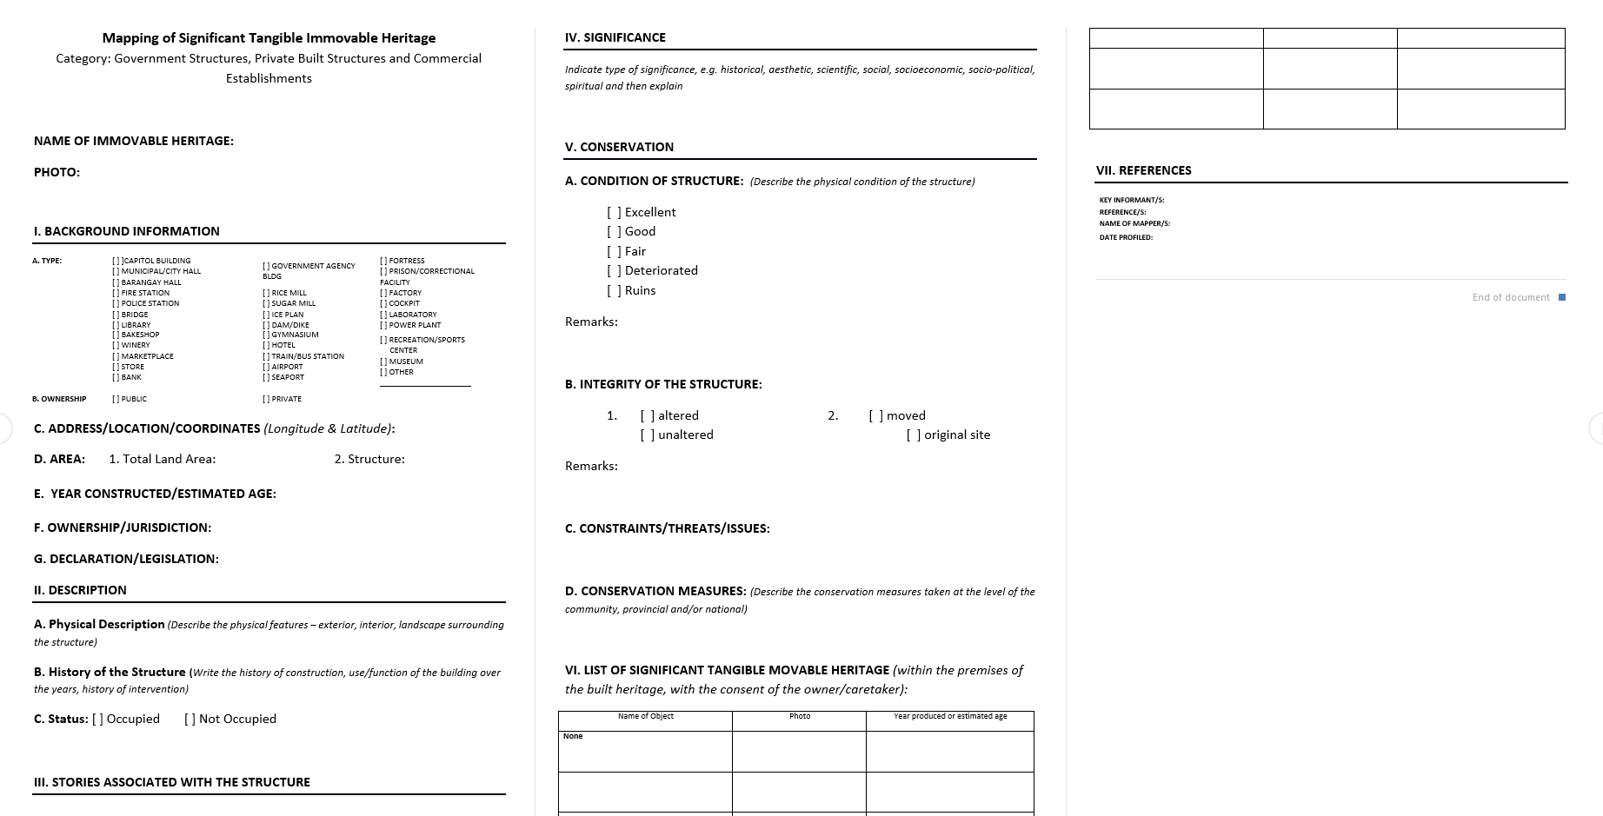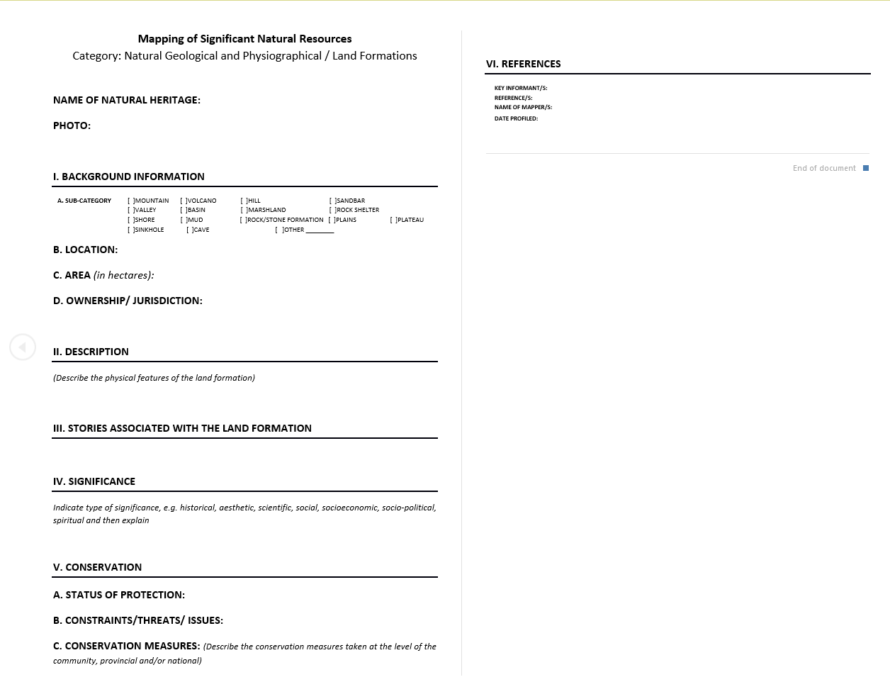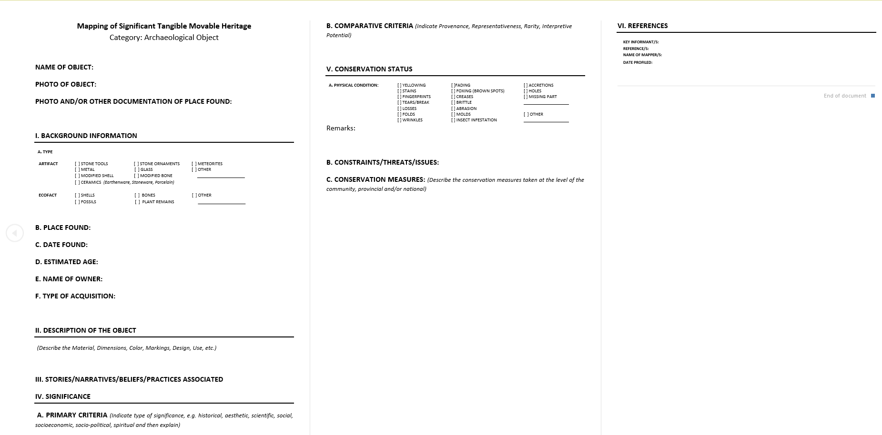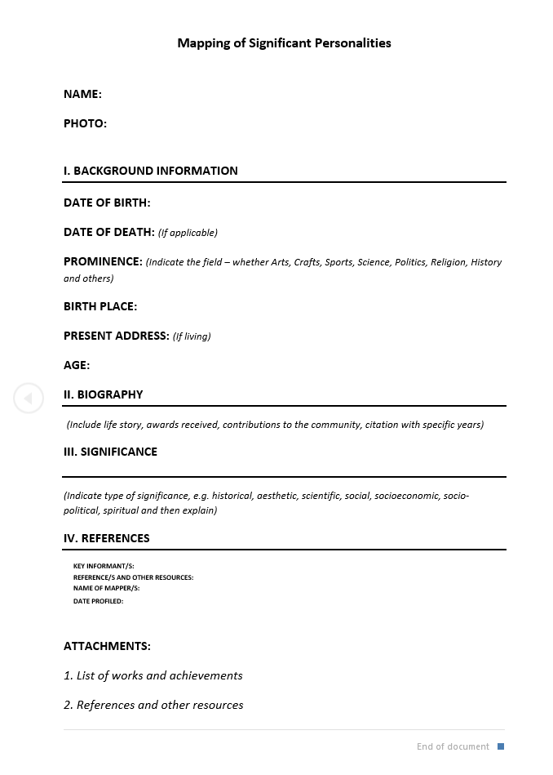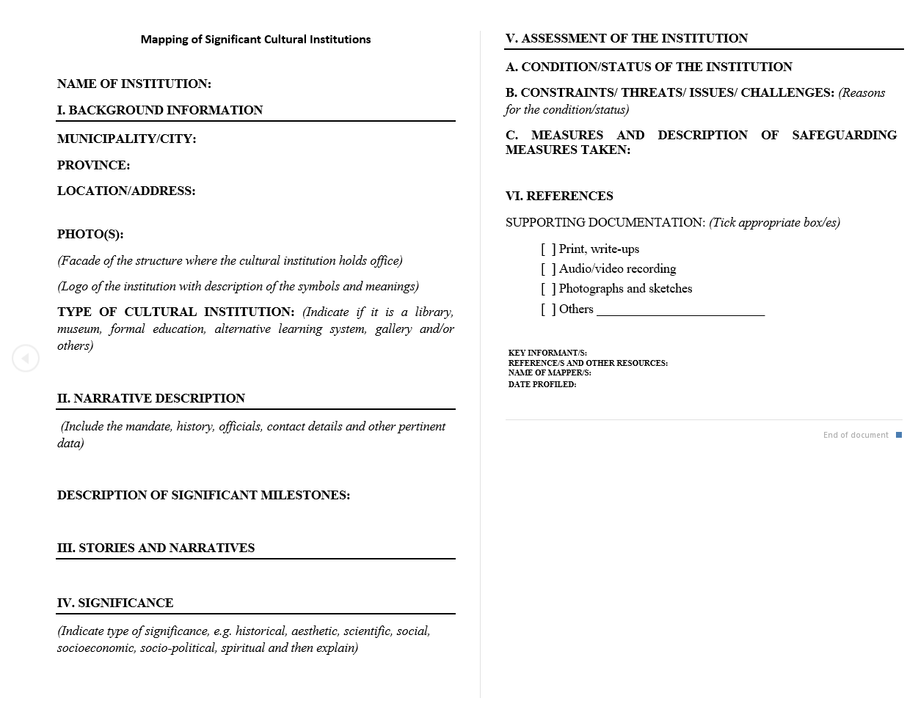

(Asan pictures niyo ?)
AUSTRIA, JEM CARLO G.
Jemcarlo46@gmail.com| 09538563123 | Mangatarem, Pangasinan
https://github.com/jemhakdog

PERSONAL PROFILE
Energetic Software Engineer with hands-on experience developing intelligent automation tools, management portals, and responsive developer utilities. Strong background in Python-driven backend development, database management, and intelligent document processing. Adept at turning complex workflows from automated exam generation to high-fidelity UI builders into clean, reliable, and user-centric software solutions.

EDUCATIONAL BACKGROUND
Primary : BCC
Secondary : Mangatarem National High School
Tertiary : Mangatarem I Central School

PROJECT(S)
Interactive Digital Cultural Map & Tourism System
- Co-developed a mapping and local tourism platform for Mangatarem, Pangasinan, coordinating directly with municipal tourism officials for data collection.
- Designed robust system architectures, data flow diagrams, and relational database schemas to manage cultural assets and local registries.
- Built interactive frontend features that render spatial data and localized travel information smoothly.
AI Flashcard Maker & Exam Simulator
- Built an automated study application that parses uploaded PDFs and images to instantly generate functional flashcards and practice exams.
- Integrated intelligent document processing to extract unstructured data and format it into structured question-and-answer pairs.
- Implemented skeleton loading and modern UI components to keep the user experience fast and responsive during heavy data processing.
OJT Management & Tracking Suite
- Designed a data management system to track On-the-Job Training workflows, shift attendance, and daily internship logs.
- Created automated logging features to streamline report submissions and map placement locations.
- Structured a secure relational database backend to maintain tamper-proof, accurate hours for institutional review.

Dynamic UI Component Builder
- Developed a developer utility tool that allows users to construct, preview, and customize modern frontend layouts in real time.
- Optimized script execution and asset rendering to guarantee layout stability and eliminate visual performance lag.

TECHNICAL SKILLS & COMPETENCIES
• Programming Languages: Python 3.12
• Databases: Supabase
• Libraries & Frameworks: HTML Libraries, AOS (Animate On Scroll)
• Tools & Package Management: uv
• Development Techniques: Lazy loading, skeleton screen loading

AUSTRIA, JEM CARLO G.
Jemcarlo46@gmail.com| 09538563123 | Mangatarem, Pangasinan

PERSONAL PROFILE

EDUCATIONAL BACKGROUND
Primary : BCC
Secondary : Mangatarem National High School
Tertiary : Mangatarem I Central School

PROJECT(S)

TECHNICAL SKILLS & COMPETENCIES

AUSTRIA, JEM CARLO G.
Jemcarlo46@gmail.com| 09538563123 | Mangatarem, Pangasinan

PERSONAL PROFILE

EDUCATIONAL BACKGROUND
Primary : BCC
Secondary : Mangatarem National High School
Tertiary : Mangatarem I Central School

PROJECT(S)

TECHNICAL SKILLS & COMPETENCIES

AUSTRIA, JEM CARLO G.
Jemcarlo46@gmail.com| 09538563123 | Mangatarem, Pangasinan

PERSONAL PROFILE

EDUCATIONAL BACKGROUND
Primary : BCC
Secondary : Mangatarem National High School
Tertiary : Mangatarem I Central School

PROJECT(S)

TECHNICAL SKILLS & COMPETENCIES

